**BIT302 SOFTWARE ENGINEERING**

**Assignment 2**

HELP COVID-19 Testing Information System (CTIS) Website – Design Specification Document



**Team Leader**

I Made Siva Aditya Surya / E1800176

[mdsivaaditya@gmail.com](mailto:mdsivaaditya@gmail.com)

**Member**

Ida Bagus Gede Awidya Andika / E1800182

[awidyaandika@gmail.com](mailto:awidyaandika@gmail.com)

2021

Table of Contents

**1.** **Introduction** 1

**1.1.** **Requirements Specifications** 2

**1.2.** **Use Case Diagram** 5

**2.** **Design Specification** 6

**2.1.** **Architectural Design** 6

**2.1.1.** **Design Class Diagram** 6

**2.1.2.** **ERD** 7

**2.2.** **System Design** 16

**2.2.1.** **System Sequence Diagram + Contract** 16

**2.2.2.** **Database Design & Data Dictionary** 20

**3.** **Iteration 1** 24

**3.1.** **Identification** 24

**3.2.** **Test Objectives** 25

**3.3.** **Test Plan** 25

**3.4.** **Test Results** 26

**3.4.1.** **Unit Testing** 26

**3.4.2.** **Integration Testing** 32

**3.4.3.** **System Testing** 36

**3.5.** **Test Analysis Report** 47

**3.6.** **Updated Gantt Chart** 48

**3.7.** **Collaboration via GitHub** 49

**Bibliography** 51

**Appendix A: Peer Presentation Evaluation** 52

1. **Introduction**

HELP CTIS Website project was initiated with aims to develop a website information system to administers test and enable direct-to-patient report of COVID-19 test results. Some of our project objectives is to create a design specification and test plan, which will be included in this document.

The design specification document includes all the requirements of the project, architectural design of the system, and system design of the system. The architectural design defines how the relationship/structures of the system components and how they interact with each other. We listed design class diagram, entity relationship diagram, site map, and generic user experience/wireframes in this document as part of our architectural design. The system designs of the project in form of system sequence diagrams, contracts, and database design (data dictionary) are included in this document to ensure the system component would meet all the requirements which are determined in assignment 1 document.

We have done the testing of on the first iteration prototype our system and compiled the result in this document. Test plan is done to finding errors, check the quality of the system, and make sure that the end result meets the functional and non-functional requirements.

* 1. **Requirements Specifications**

There were no updates on any of the requirements during the first iteration of this project. The functional and non-functional requirements stated on the first assignment is put into table for better identification, as follows:

Functional Requirements

|  |  |  |
| --- | --- | --- |
| Functional Requirement No. | Description | Associated User |
| FR1 | A menu to login to the system with username and password verification. | All |
| FR2 | View testing history menu that shows the patient’s Covid-19 test data and result in chronological order. | Patient |
| FR3 | Test report menu that shows a list of all test that have been administered in the test centre that the officer is employed at are shown in chronological order. | Test Centre Officer |
| FR4 | Test centre officer menu that shows a list of all test centre officer (regardless of position) that is employed in the test centre. | Test Centre Officer |
| FR5 | Test kit menu that shows a list of all test kit that the test centre has and the stock. | Test Centre Officer |
| FR6 | A form in patient test menu to record new test data with appropriate label and column to fill out patient data, patient type, and symptoms and a button to record the data. | Tester |
| FR7 | Update test result function in patient test menu that shows a list of test data in chronological order with a button to edit test result, the button will navigate to update test result page with appropriate form to fill out the result data and a button to update the test result. | Tester |
| FR8 | Register test centre page when the manager first login to system, to verify and record the manager’s test centre into database. | Test Centre Manager |
| FR9 | Record officer function in test centre officer menu that includes a form with appropriate label and column to fill out new officer data, a username verification, and a button to record the data. | Test Centre Manager |
| FR10 | Record tester function in test centre officer menu that includes a button to update the officer position to tester if the manager wants to change the position of an existing officer to tester, or a form to fill out officer data if the manager wants to record new officer with the position of tester. | Test Centre Manager |
| FR11 | Manage test kit menu that includes a list of all test kit available with its stock, a button to input new test kit, and a button to update test kit details (stock). | Test Centre Manager |
| FR12 | A button to log out from the system. | All |

Non-functional Requirements

|  |  |  |
| --- | --- | --- |
| Non-functional Requirement No. | Name | Description |
| NF1 | Correctness | All the information that is recorded to the system and provided by the system must be accurate, complete, and up-to-date. To support this requirement, the system must have a data verification every time a data is about to be recorded to the database. |
| NF2 | Efficiency | The system should be lightweight and does not require extensive amount of hardware resources to perform a function. |
| NF3 | Privacy of Information | Patient and officer personal data that is stored in the database must be properly consent and regulated. |
| NF4 | Security & Integrity | The system must control unauthorized person from accessing and changing the data. The only one who can record and update test centre officer data and position is the manager. The only who can record and update patient’s test data and test result is the tester. |
| NF5 | Usability | Tthe system should be easy to learn, understand, and operate all the features. To support this requirement, a good design for the website with appropriate icon for buttons and menu should be implemented. |
| NF6 | Reliability | The system should perform all its functions as intended without failure. |

* 1. **Use Case Diagram**

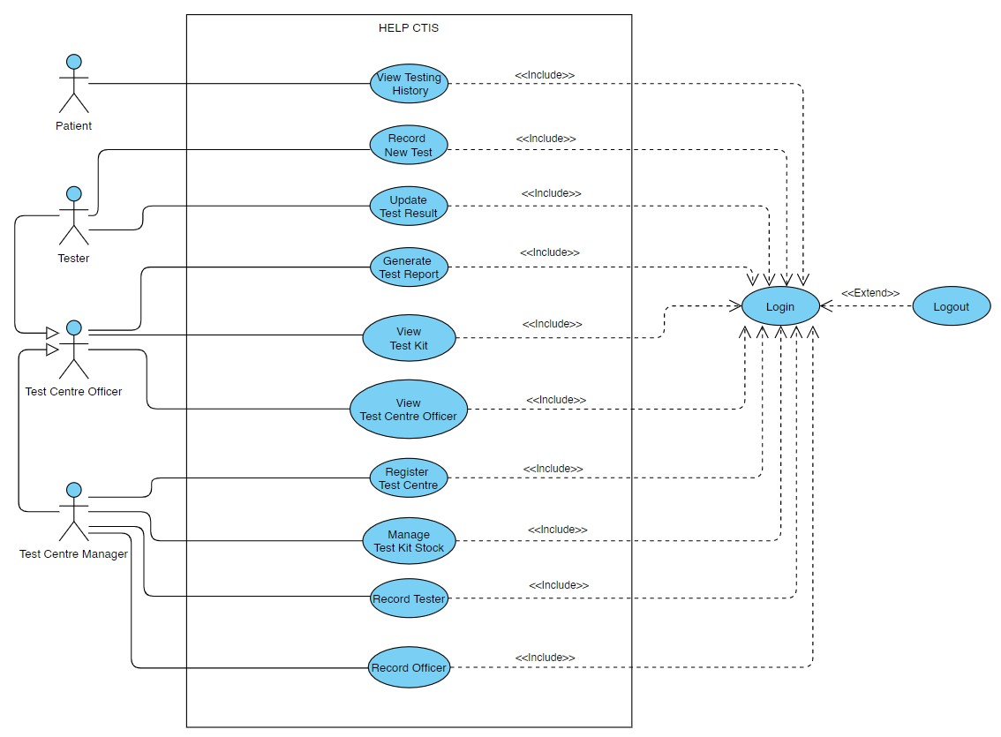

Figure 1. Use Case Diagram

There were no updates on the use case diagram during the first iteration of this project. The project will still go with the 12 use cases that were already stated on the first assignment. Three out of 12 use cases, namely: login, logout, and register test centre were developed and tested in the first iteration of the first project. The remaining use cases are to be developed in the second iteration of the project.

1. **Design Specification**
   1. **Architectural Design**
      1. **Design Class Diagram**

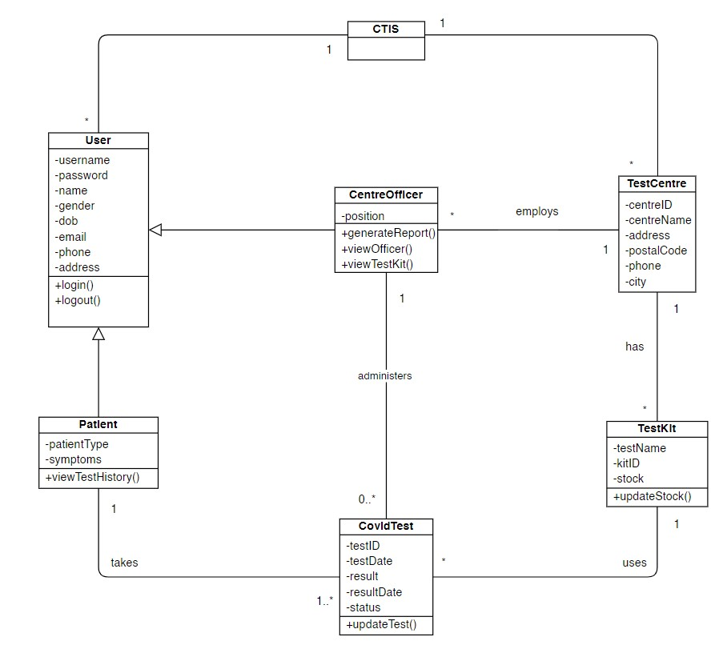

Figure 2. Design Class Diagram

There were no updates on the design class diagram during the first iteration of this project. Three out of 12 use cases that were developed in the first iteration of the first project requires no changes to the class diagram. The remaining use cases that are to be developed in the second iteration of the project may change the design and details of the class diagram, further details of the changes to the diagram will be described in the next iteration documents.

* + 1. **ERD**

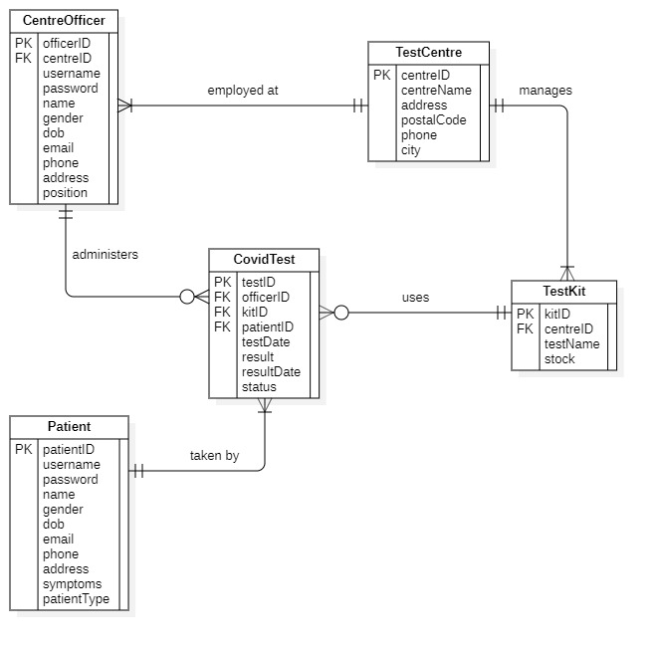

Figure 3. Entity Relationship Diagram

* + 1. **Site Map**

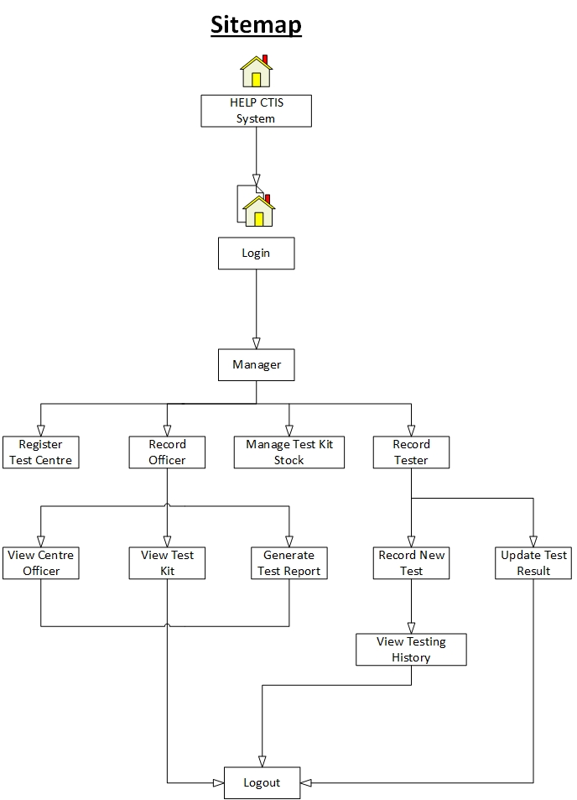

Figure 4. HELP CTIS Sitemap

* + 1. **Generic User Experience/Wireframe**

1. Login

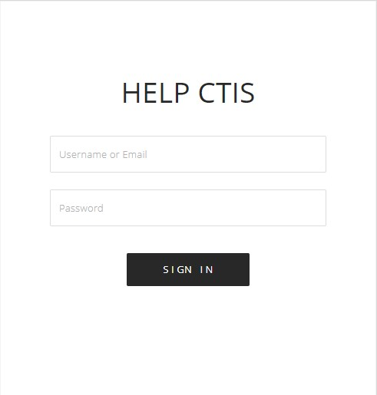

Figure 5. Login Wireframe

1. Dashboard (All User)

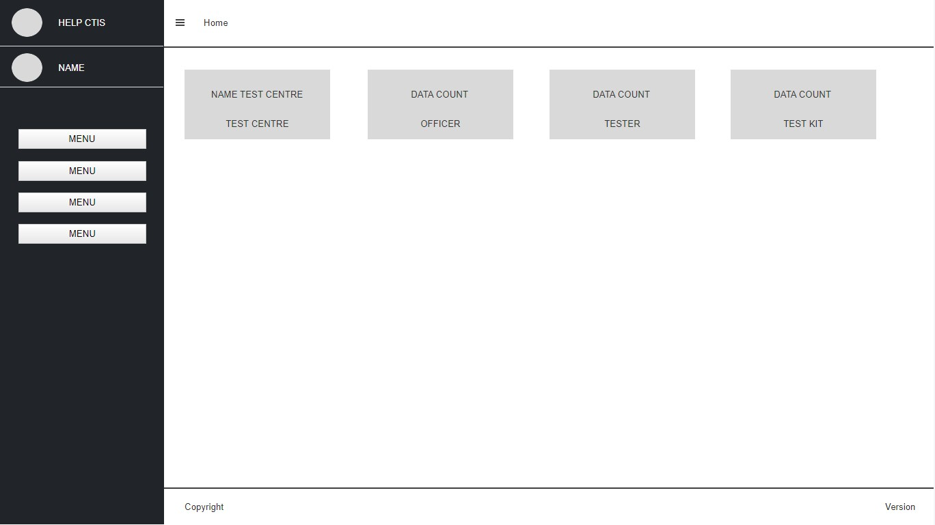

Figure 6. Dashboard Wireframe

1. Register Test Centre

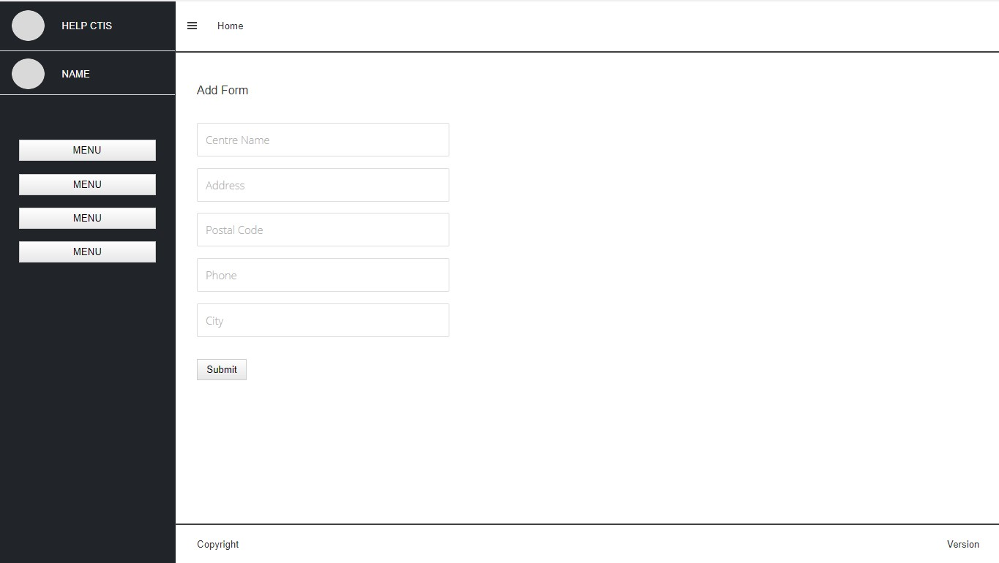

Figure 7. Register Test Centre Wireframe

1. Record Officer

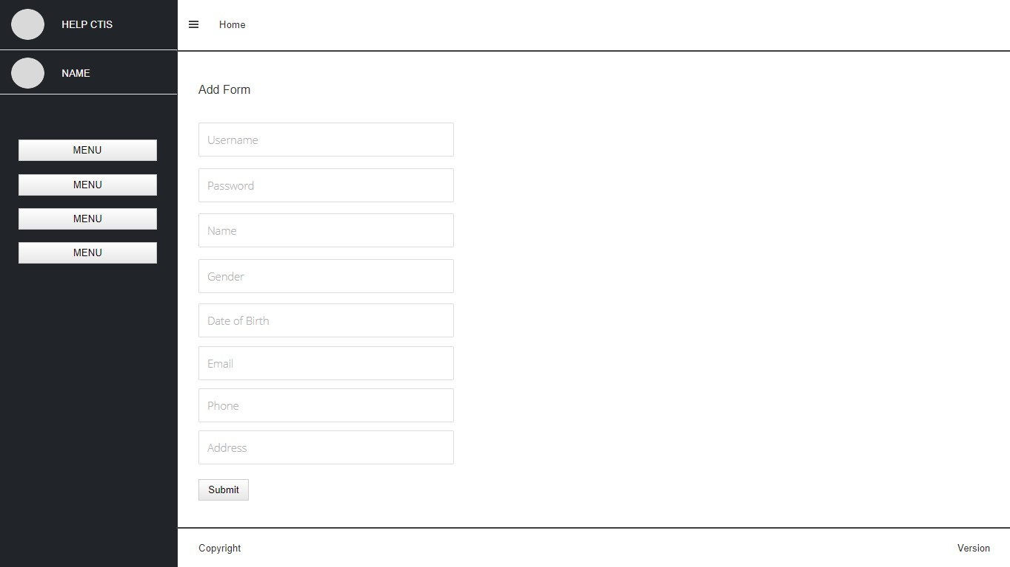

Figure 8. Record Officer Wireframe

1. Record Tester

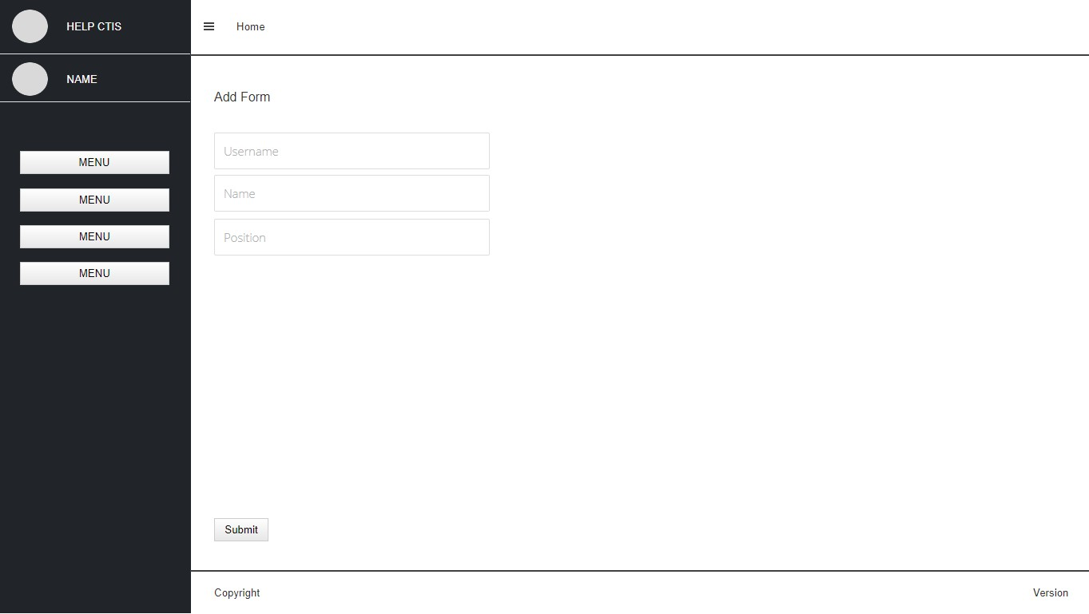

Figure 9. Record Tester Wireframe

1. View Test Kit

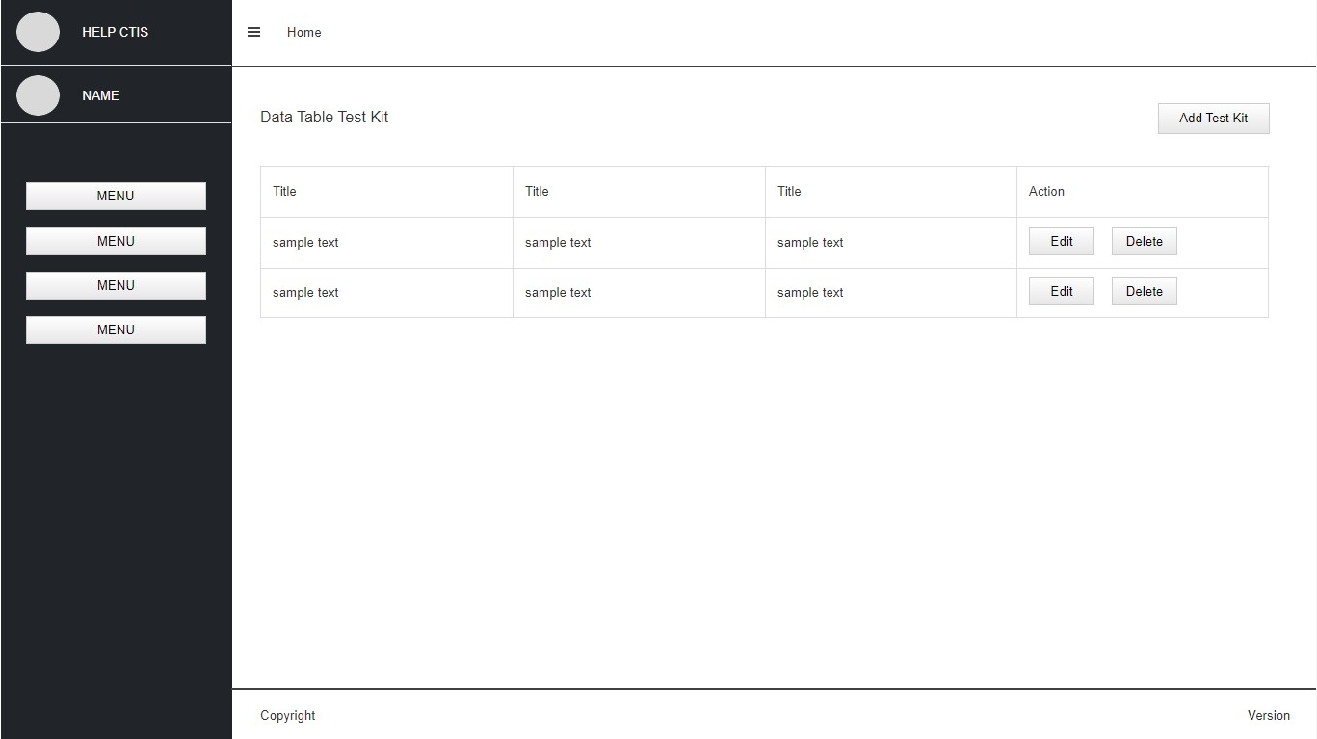

Figure 10. View Test Kit Wireframe

1. Manage Test Kit

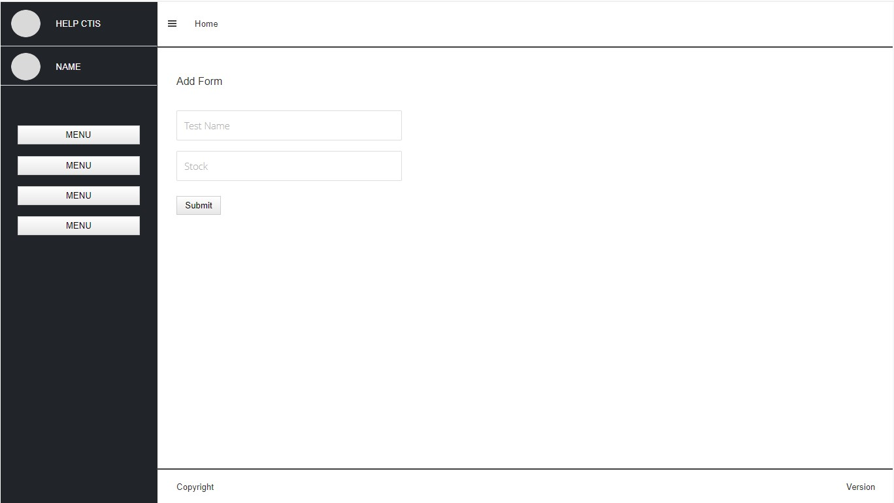

Figure 11. Manage Test Kit (Add) Wireframe

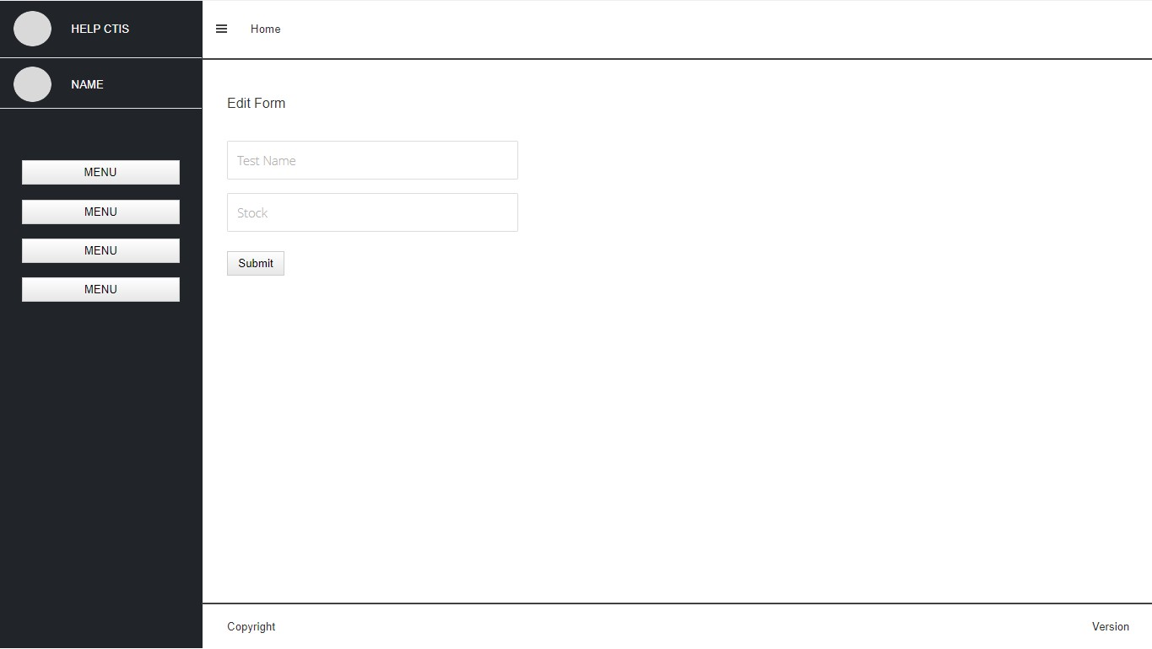

Figure 12. Manage Test Kit (Edit) Wireframe

1. Generate Test Report

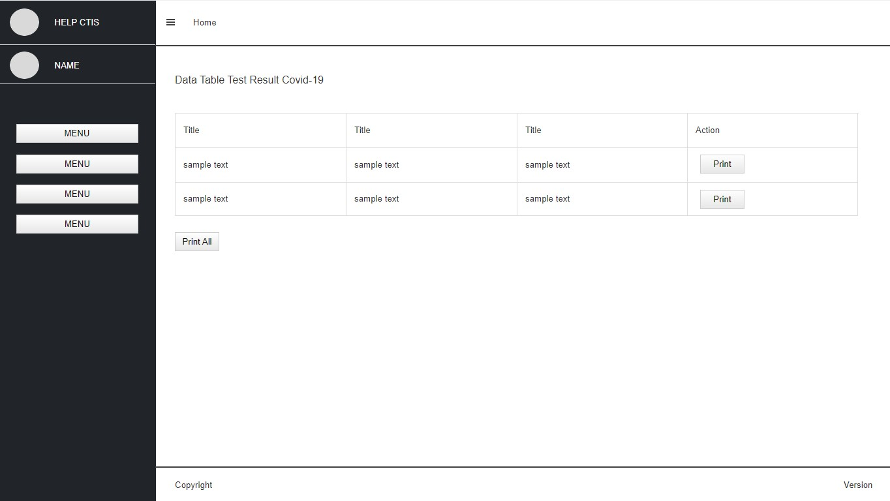

Figure 13. Generate Test Report Wireframe

1. View Test Centre Officer

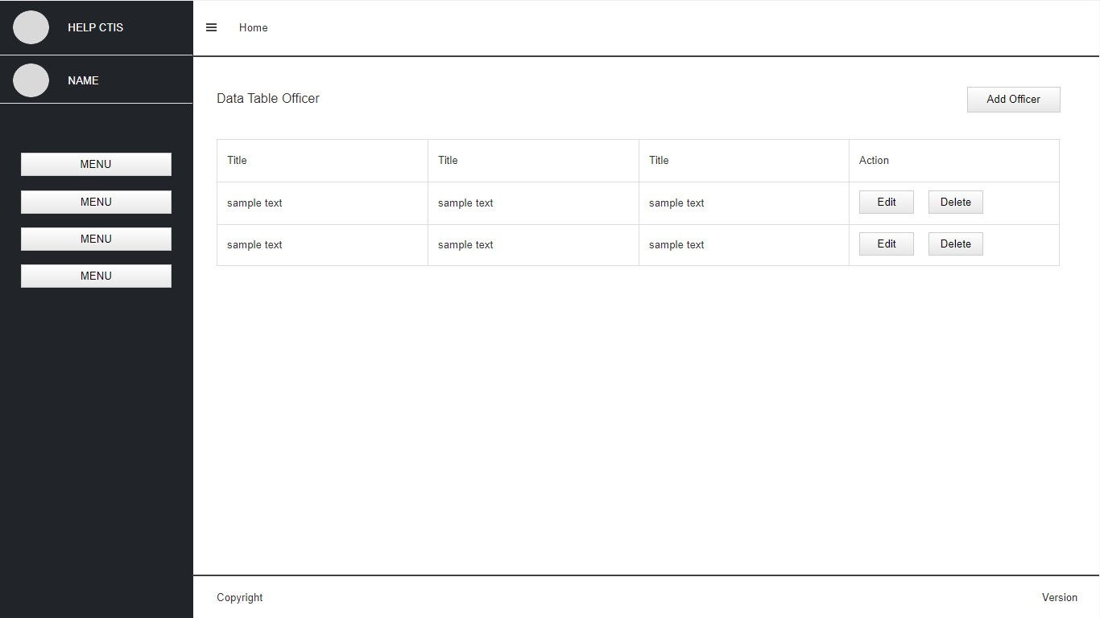

Figure 14. View Test Centre Officer Wireframe

1. Record New Test

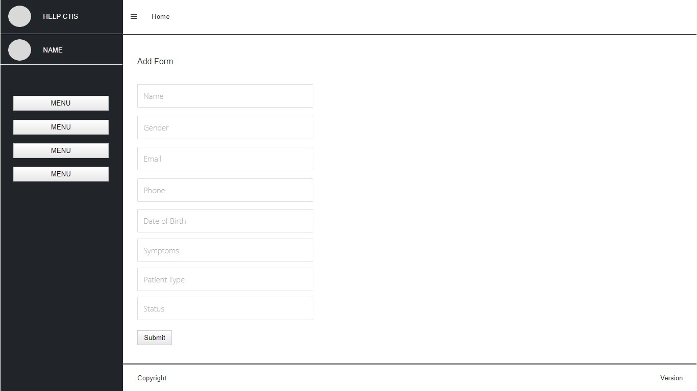

Figure 15. Record New Test Wireframe

1. Update Test Result

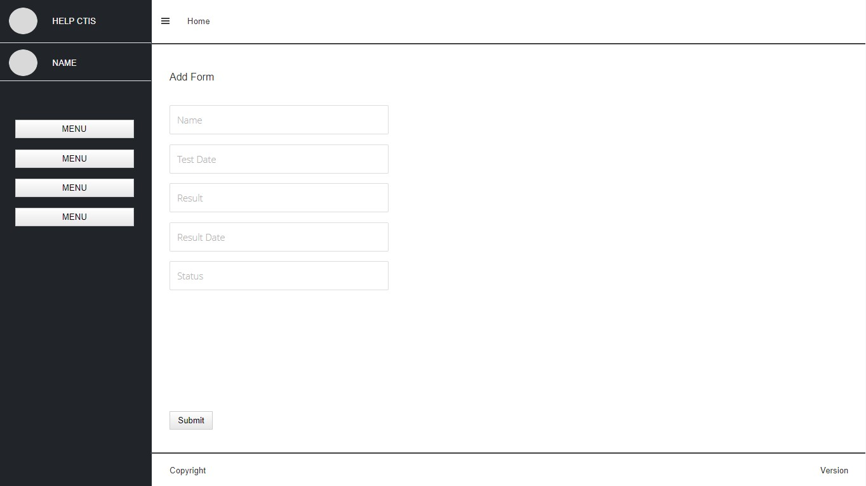

Figure 16. Update Test Result Wireframe

1. View Testing History

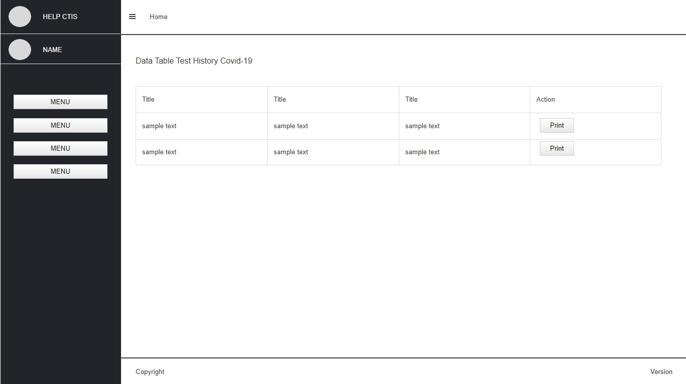

Figure 17. View Testing History Wireframe

* 1. **System Design**
     1. **System Sequence Diagram + Contract**

1. Login

Prepared by: Ida Bagus Gede Awidya Andika

* System Sequence Diagram

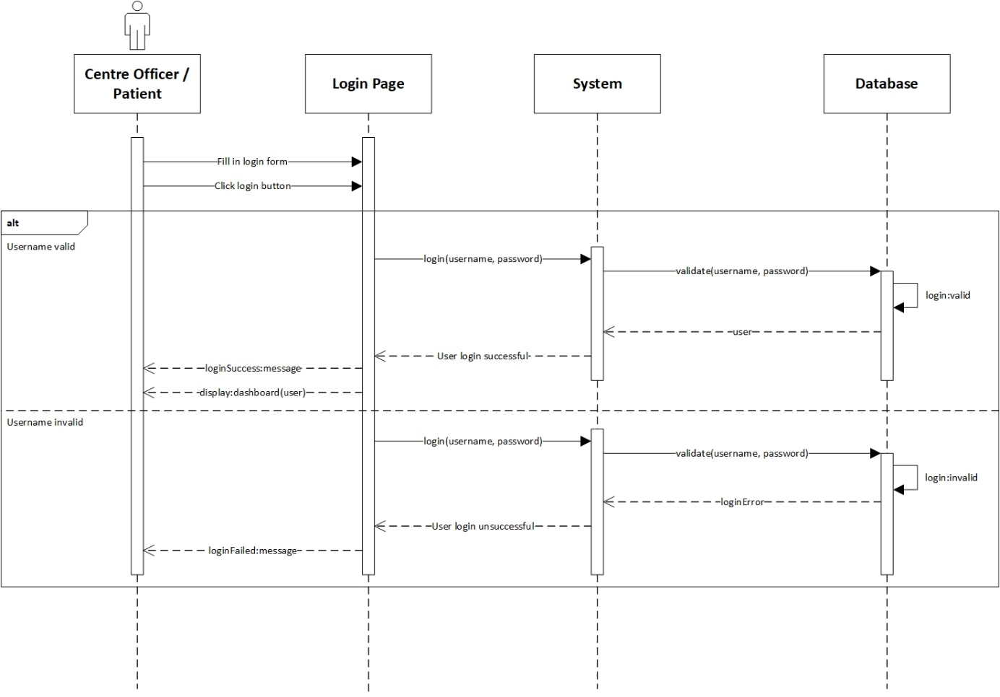

Figure 18. Login System Sequence Diagram

* Contract

|  |  |
| --- | --- |
| **Cross References** | **Login** |
| Operation | login(username, password) |
| Responsible | To access the user’s dashboard. |
| Pre-conditions | * User object must be available * A valid username and password |
| Post-conditions | * Session was created (instance creation) * Session was associated with the User (association formed) |
| **Cross References** | **Login** |
| Operation | login(username, password) |
| Responsible | To access the user’s dashboard. |

1. Logout

Prepared by: Ida Bagus Gede Awidya Andika

* System Sequence Diagram

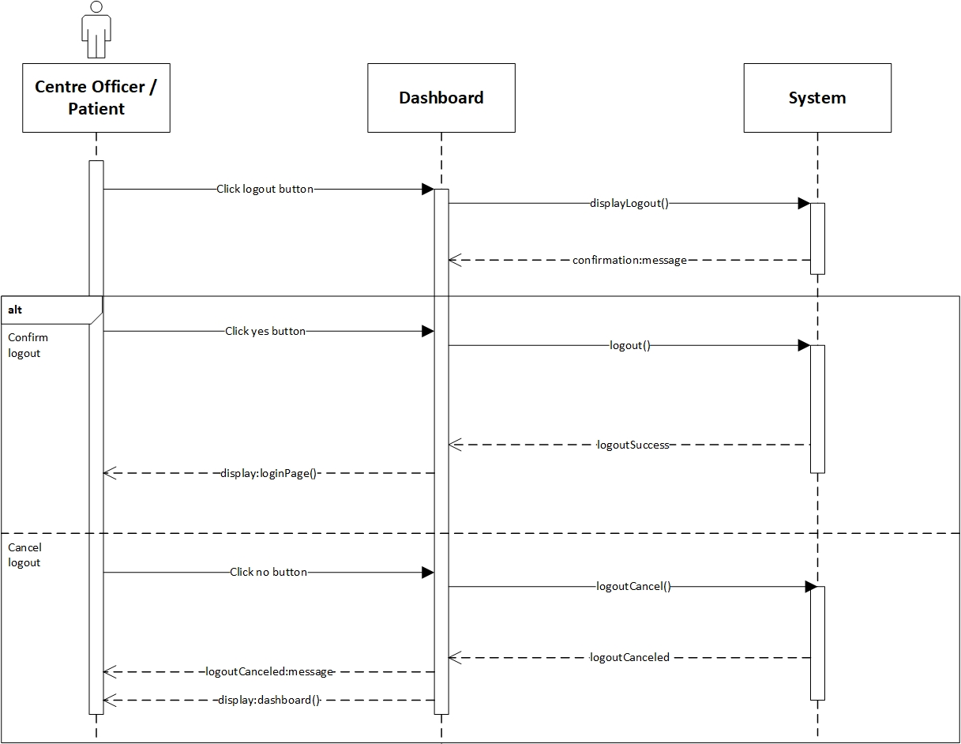

Figure 19. Logout System Sequence Diagram

* Contract

|  |  |
| --- | --- |
| **Cross References** | **Logout** |
| Operation | logout() |
| Responsible | To log out or exit from the system |
| Pre-conditions | * User object must be available * Session must already be created * Confirm to logout |
| Post-conditions | Session was destroyed (instance deletion) |
| **Cross References** | **Logout** |
| Operation | logoutCancel() |
| Responsible | To cancel log out or exit from the system |
| Pre-conditions | * User object must be available * Session must already be created * Confirm to cancel logout |
| Post-conditions | Session was not destroyed |

1. Register Test Centre

Prepared by: Ida Bagus Gede Awidya Andika

* System Sequence Diagram

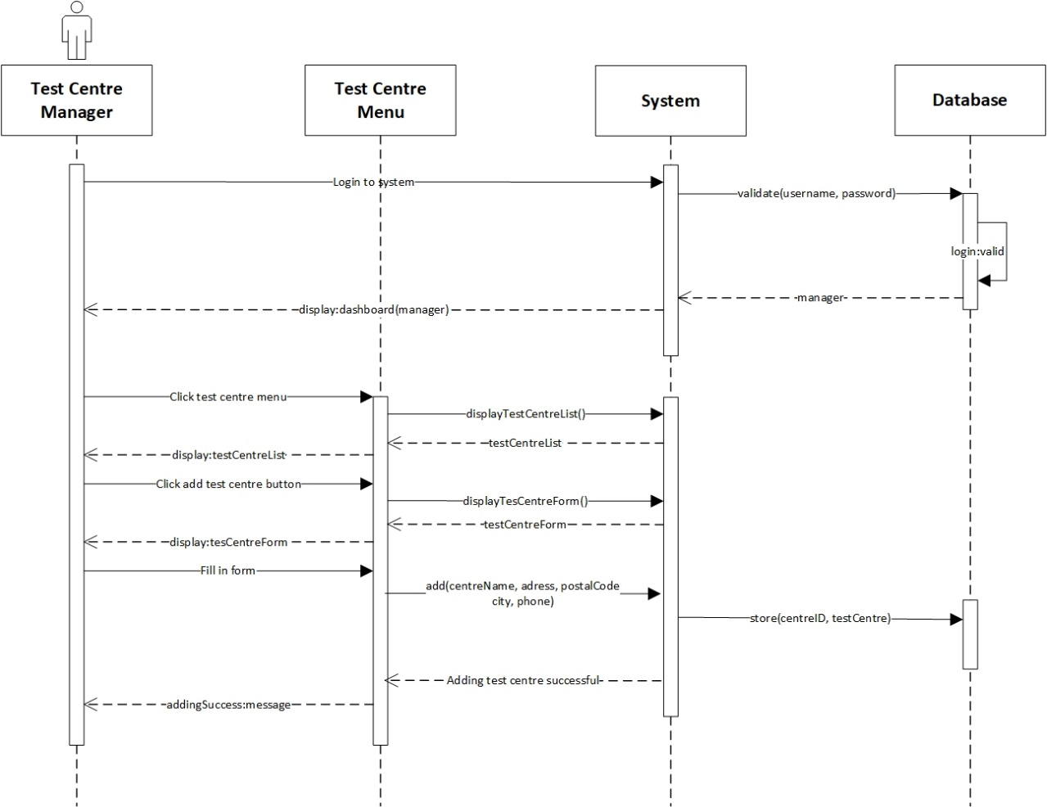

Figure 20. Register Test Centre System Sequence Diagram

* Contract

|  |  |
| --- | --- |
| **Cross References** | **Register Test Centre** |
| Operation | login(username, password) |
| Responsible | To access the manager’s dashboard. |
| Pre-conditions | * Manager object must be available * A valid username and password |
| Post-conditions | * Session was created (instance creation) * Session was associated with the Manager (association formed) |
| **Cross References** | **Register Test Centre** |
| Operation | add(centreName, address, postalCode, city, phone) |
| Responsible | To register test centre. |
| Pre-conditions | * Manager object must be available * Session must already be created * Test centre data is available |
| Post-conditions | * TestCentre was created (instance creation) * centreId was generated (attribute modification) * Manager was associated with the TestCentre (association formed) |

* + 1. **Database Design & Data Dictionary**

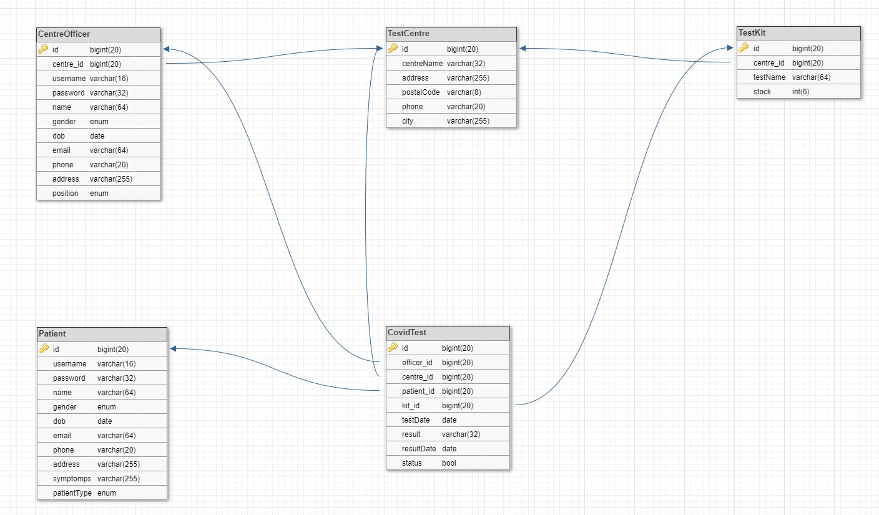

Figure 21. Database Design

1. CentreOfficer Table

|  |  |  |  |  |
| --- | --- | --- | --- | --- |
| **Field Name** | **Data Type** | **Field Size** | **Description** | **Example** |
| id | bigint | 20 | A test centre officer’s unique ID number | 1 |
| centre_id | bigint | 20 | ID number of the test centre that a test centre officer is employed at | 1 |
| username | varchar | 16 | Test centre officer unique account username for login | manager |
| password | password | 32 | Test centre officer account password for login | mangacan |
| name | varchar | 64 | Name of test centre officer | Manager |
| gender | enum |  | Gender of test centre officer (Male or Female) | Male |
| dob | date |  | Birth date of test centre officer | 1998-01-03 |
| email | varchar | 64 | Email of test centre officer | [manager@gmail.com](mailto:manager@gmail.com) |
| phone | varchar | 20 | Phone number of test centre officer | 085734903945 |
| address | varchar | 255 | Home address of test centre officer | Jl. Perum Permai, No: 22 |
| position | enum |  | Employee position of test centre officer | manager |

1. TestCentre Table

|  |  |  |  |  |
| --- | --- | --- | --- | --- |
| **Field Name** | **Data Type** | **Field Size** | **Description** | **Example** |
| id | bigint | 20 | A test centre’s unique ID number | 1 |
| centreName | varchar | 32 | Name of test centre | Bali Med |
| address | varchar | 255 | Address of test centre | Jl. Mahendra 12x |
| postalCode | varchar | 8 | Postal code of the address | 80119 |
| phone | varchar | 20 | Hotline call centre number of test centre | (0361) 423215 |
| city | varchar | 50 | City/region where the test cente is located | Denpasar |

1. TestKit Table

|  |  |  |  |  |
| --- | --- | --- | --- | --- |
| **Field Name** | **Data Type** | **Field Size** | **Description** | **Example** |
| id | bigint | 20 | A test kit’s unique ID number | 1 |
| centre_id | bigint | 20 | ID number of the test centre that owns the test kit | 1 |
| testName | varchar | 64 | Name of test kit | COVID-19 Antigen Rapid Testing (RTK-Ag) |
| stock | int | 6 | Available stock of test kit | 100 |

1. Patient Table

|  |  |  |  |  |
| --- | --- | --- | --- | --- |
| **Field Name** | **Data Type** | **Field Size** | **Description** | **Example** |
| id | bigint | 20 | A patient’s unique ID number | 1 |
| username | varchar | 16 | Patient unique account username for login | roger |
| password | varchar | 32 | Patient account password for login | captainroger |
| name | varchar | 64 | Name of patient | Roger Fritz |
| gender | enum |  | Gender of patient (Male or Female) | Male |
| dob | date |  | Birth date of patient | 1991-04-03 |
| email | varchar | 64 | Email of patient | rogercpt@gmail.com |
| phone | varchar | 20 | Phone number of patient | 08573492304 |
| address | varchar | 255 | Home address of patient | Jl. Beringin no: 17 |
| symptoms | varchar | 255 | COVID-19 symptoms of patient | Fever, sore throat, loss of taste and smell, dry cough, and difficulty of breathing. |
| patientType | enum |  | Type of patient (“returnee”,  “quarantined”, “close contact”, “infected”, or “suspected”) | Returnee |

1. CovidTest Table

|  |  |  |  |  |
| --- | --- | --- | --- | --- |
| **Field Name** | **Data Type** | **Field Size** | **Description** | **Example** |
| id | bigint | 20 | A test centre’s unique ID number | 1 |
| officer_id | bigint | 20 | ID number of the test centre officer who administered the test | 1 |
| patient_id | bigint | 20 | ID number of the patient who took the test | 1 |
| kit_id | bigint | 20 | ID number of test kit which is used to perform the test | 1 |
| testDate | date |  | The date on which the test is performed | 2021-04-03 |
| result | varchar | 100 | Result of the test | HEALTHY and NEGATIVE rapid test results with the COVID-19 Rapid Test |
| resultDate | date |  | The date on which the test results are issued | 2021-04-05 |
| status | enum |  | Status of the test (“pending” or “completed”) | Completed |

1. **Iteration 1**
   1. **Identification**

For the first iteration of this project, we developed and tested three out of 12 use cases namely login, logout, and register test center which all are developed by Ida Bagus Gede Awidya Andika. All the remaining use cases will be developed and tested during the second iteration of our project

|  |  |  |  |
| --- | --- | --- | --- |
| No | Use Case | Developed by | Development & Testing |
| 1 | Login | Ida Bagus Gede Awidya Andika | Iteration 1 |
| 2 | Logout | Ida Bagus Gede Awidya Andika | Iteration 1 |
| 3 | Register Test Centre | Ida Bagus Gede Awidya Andika | Iteration 1 |
| 4 | Manage Test Kit Stock | Ida Bagus Gede Awidya Andika | Iteration 2 |
| 5 | Record Officer | I Made Siva Aditya Surya | Iteration 2 |
| 6 | Record Tester | I Made Siva Aditya Surya | Iteration 2 |
| 7 | View Test Kit | Ida Bagus Gede Awidya Andika | Iteration 2 |
| 8 | View Test Centre Officer | Ida Bagus Gede Awidya Andika | Iteration 2 |
| 9 | Generate Test Report | I Made Siva Aditya Surya | Iteration 2 |
| 10 | Record New Test | I Made Siva Aditya Surya | Iteration 2 |
| 11 | Update Test Result | I Made Siva Aditya Surya | Iteration 2 |
| 12 | View Testing History | I Made Siva Aditya Surya | Iteration 2 |

* 1. **Test Objectives**

The test objectives of the testing for the result of the first iteration of our project are to test the three use cases developed in this iteration based on the functional and non-functional requirements. Here is the list of the objectives that have to be fulfilled for the first iteration testing of this project:

* The system can be used on various computer devices such as PCs, laptops and smartphones
* The user interface runs according to its function, from buttons, links, forms, pages according to the role / position of the user
* The system can direct users to their dashboards when logged in based on their position
* All users can end their session via the logout process
* Manager can add Test Center data
  1. **Test Plan**

|  |  |  |  |
| --- | --- | --- | --- |
| Type of Testing | Strategy/Approach | Tools (if any) | Schedule |
| Unit Testing   * Login * Record Test Centre * Logout | Black Box | PHP Storm | From gantt chart  4/5/21 – 4/6/21 |
| Integration Testing | Black Box | PHP Storm | From gantt chart  4/7/21 – 4/7/21 |
| Functional Testing | Black Box | PHP Storm | From gantt chart  4/7/21 – 4/7/21 |
| Non-Functional Testing | Black Box | Google Chrome | From gantt chart  4/8/21 – 4/8/21 |

* 1. **Test Results**
     1. **Unit Testing**

1. Login

The findUsername function located in the loginController functions to record email and username data entered by the user.

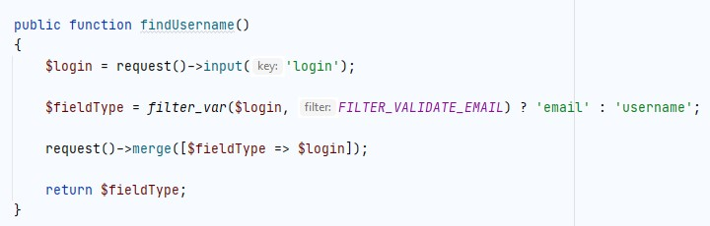

Then if the data entered by the user in accordance with the database, then the user will be direct to the dashboard according to registered role / position (this function is located in HomeController).

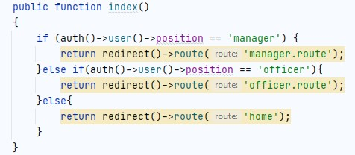

Manager Dashboard

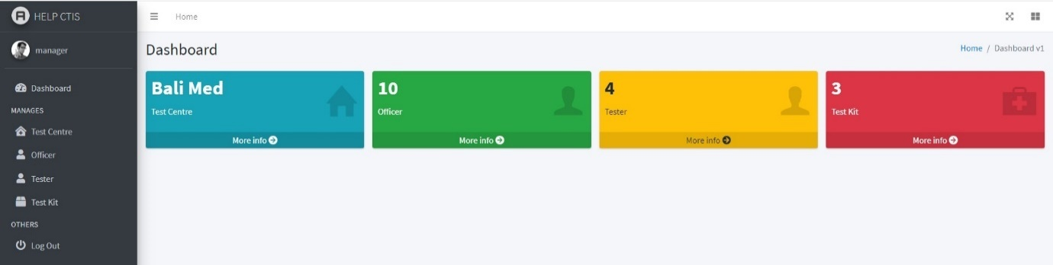

|  |  |  |  |  |
| --- | --- | --- | --- | --- |
| Test ID | R-001 | | | |
| Use Case | Login | | | |
| Test Description | Allow the user for login their account | | | |
| Source Code | if(auth()->attempt(array($fieldType => $inputVal['username'], 'password' => $inputVal['password']))){  if (auth()->user()->position == 'manager') {  return redirect()->route('manager-home');  }else if(auth()->user()->position == 'officer'){  return redirect()->route('officer-home');  }else{  return redirect()->route('home');  }  }else{  return redirect()->route('login')  ->with('error','Email & Password are incorrect.');  } | | | |
|  | Test Data | Expected Output | Actual Output | Remark(s) |
| Test Case 1: | Username :  Password: | A warning notification will be displayed | A warning notification will be displayed | Pass |
| Test Case 2: | Username: manager  Password: manager | Directed to the dashboard page | Directed to the dashboard page | Pass |
| Test Case 3: | Username: user  Password: manager | A warning message that user input wrong username will be notify | A warning message that user input wrong username will be notify | Pass |
| Test Case 4: | Username: manager  Password: user | A warning message that user input wrong password will be notify | A warning message that user input wrong password will be notify | Pass |

1. Register Test Centre

The create_test_centres_table function as a Test Center data declaration which will be used to create tables in the database.

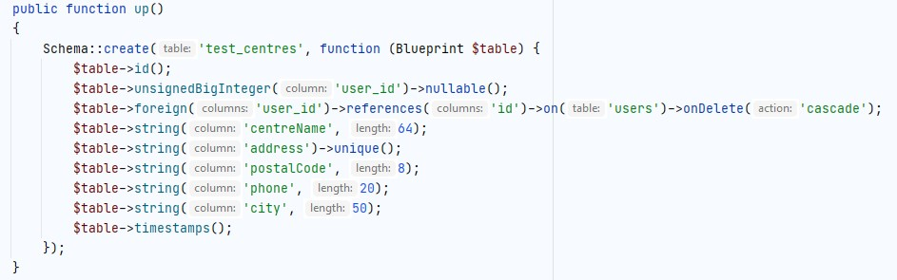

In the TestCentreController, there is store function, which is useful for storing all user input data that will later be sent to the database. Users can only enter Test Centre data once.

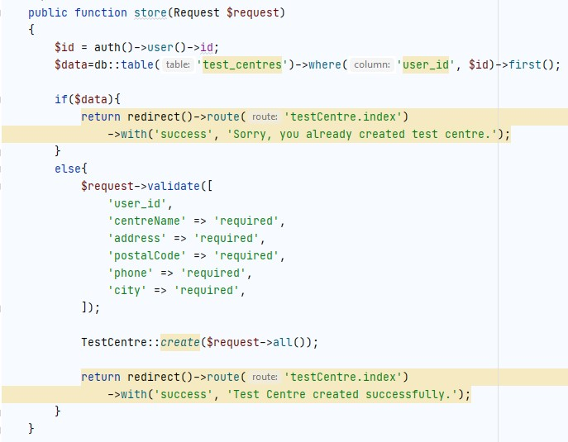

The $ fillable that is located in the TestCentre model functions to add attributes according to the column name contained in the database.

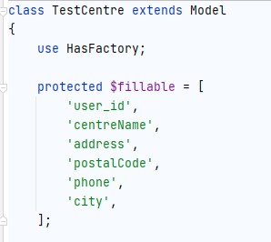

Then for the Register Test Center display located in the addtestcentre.blade.php file where the name of each attribute on the form is adjusted to the $ fillable which is located in the TestCentre model.

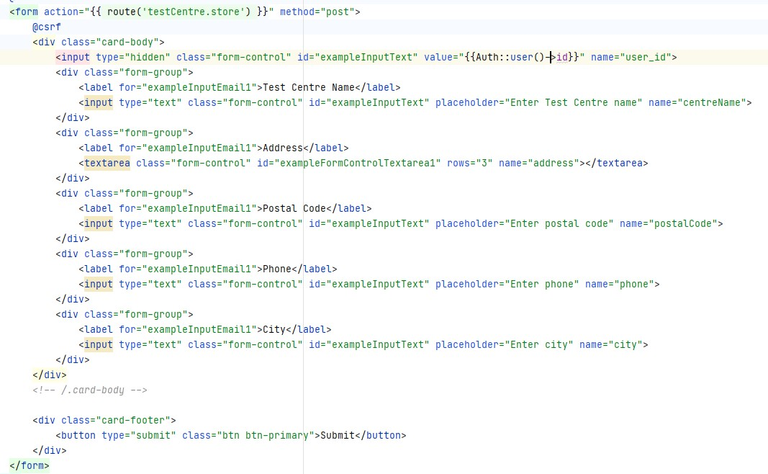

Test Centre Dashboard

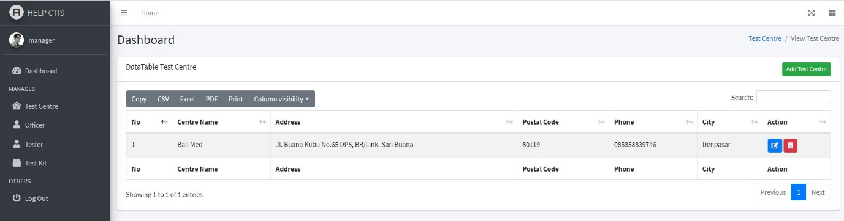

|  |  |  |  |  |
| --- | --- | --- | --- | --- |
| Test ID | R-002 | | | |
| Use Case | Register Test Centre | | | |
| Test Description | Allow the user to register for a new account. | | | |
| Source Code | $request->validate([  'centreName' => 'required',  'address' => 'required',  'postalCode' => 'required',  'phone' => 'required',  'city' => 'required',  ]);  TestCentre::create($request->all());  User::where('id', $request->user()['id'])->update([  'centre_name' => $request->centreName  ]);  return redirect()->route('testCentre.index')  ->with('success', 'Test Centre created successfully.'); | | | |
|  | Test Data | Expected Output | Actual Output | Remark(s) |
| Test Case 1: | Test Centre Name:  Address:  Postal Code:  Phone:  City: | A warning notification will be displayed | A warning notification will be displayed | Pass |
| Test Case 2: | Test Centre Name: Bali Med  Address: Jl. Buana Kubu No. 65 DPS, BR/Link. Sari Buana  Postal Code: 80119  Phone: 085858839746  City: Denpasar | The data will be displayed on the Test Centre Dashboard | The data will be displayed on the Test Centre Dashboard | Pass |
| Test Case 3: | Test Centre Name: Bali Med  Address: Jl. Buana Kubu No. 65 DPS, BR/Link. Sari Buana  Postal Code: 80119  Phone: 085858839746  City: Denpasar | A warning message already created Test Centre will be notify | A warning message already created Test Centre will be notify | Pass |

1. Logout

In the navbar display, there is a logout function which is used to end a session of a user who has logged in.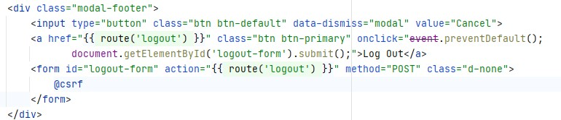

Manager Dashboard



Back to Dashboard page

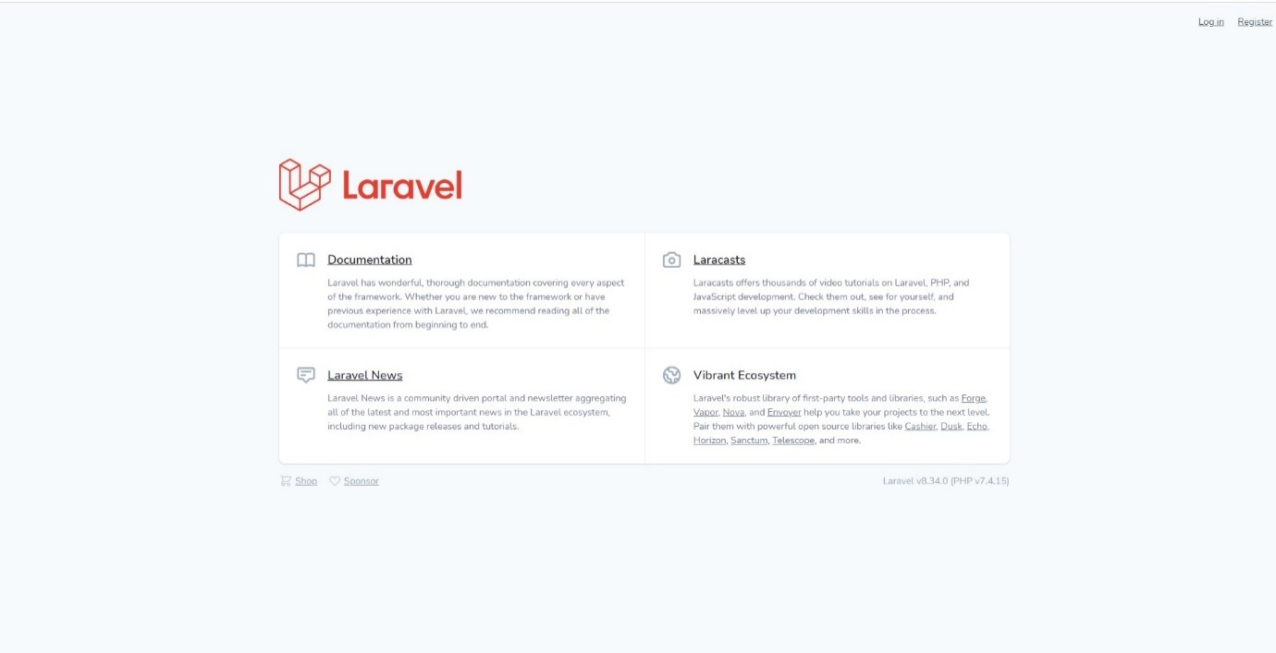

|  |  |  |  |  |
| --- | --- | --- | --- | --- |
| Test ID | R-003 | | | |
| Use Case | Logout | | | |
| Test Description | Allow the user to logout from the application | | | |
| Source Code | <a class="dropdown-item" href="{{ route('logout') }}"  onclick="event.preventDefault();  document.getElementById('logout-form').submit();">  {{ __('Logout') }}  </a> | | | |
|  | Test Data | Expected Output | Actual Output | Remark(s) |
| Test Case 1: | Click log out button | Confirmation message will be displayed | Confirmation message will be displayed | Pass |
| Test Case 2: | Click cancel button in the confirmation message | Return to previous page | Return to previous page | Pass |
| Test Case 3: | Click log out button in the confirmation message | Directed to login page | Directed to login page | Pass |

* + 1. **Integration Testing**

We used the Selenium IDE in Chrome browser Extension. The application will run based on the functions available in each use case. The results of the tests will be exported to a Python file (.py).

1. Login

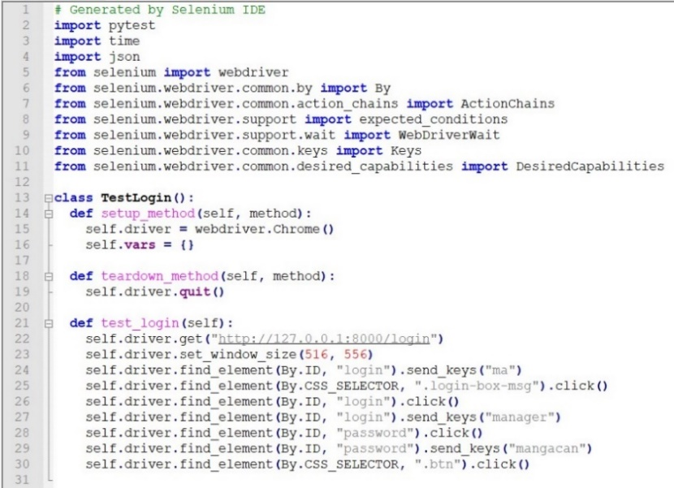

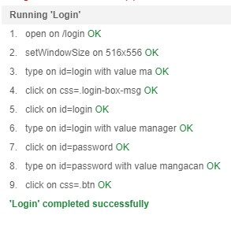

Manager : Login

|  |  |  |  |  |
| --- | --- | --- | --- | --- |
| Test ID | R-001 | | | |
| Use Case | Manager : Login | | | |
| Test Description | Allow the user for login their account | | | |
|  | Test Data | Expected Output | Actual Output | Remark(s) |
| Test Case 1: | Username :  Password: | A warning notification will be displayed | A warning notification will be displayed | Pass |
| Test Case 2: | Username: manager  Password: manager | Directed to the dashboard page | Directed to the dashboard page | Pass |
| Test Case 3: | Username: user  Password: manager | A warning message that user input wrong username will be notify | A warning message that user input wrong username will be notify | Pass |
| Test Case 4: | Username: manager  Password: user | A warning message that user input wrong password will be notify | A warning message that user input wrong password will be notify | Pass |

1. Register Test Centre

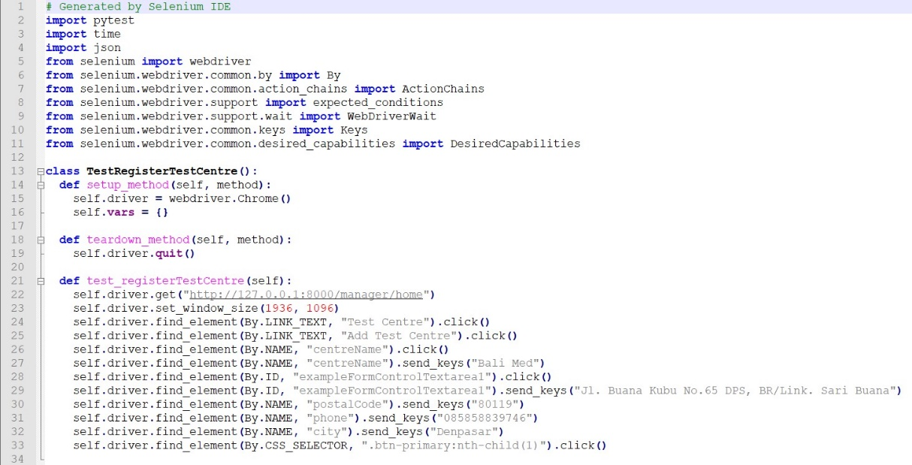

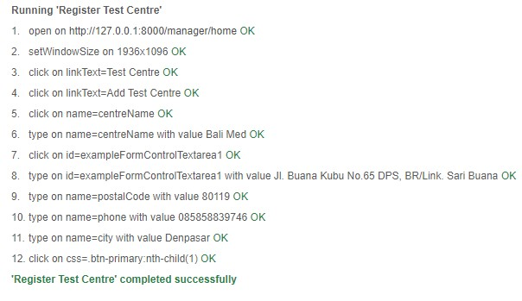

Manager : Login🡪 Register Test Centre

|  |  |  |  |  |
| --- | --- | --- | --- | --- |
| Test ID | R-002 | | | |
| Use Case | Manager : Dashboard 🡪 Register Test Centre | | | |
| Test Description | Allow the user to register for a new account. | | | |
|  | Test Data | Expected Output | Actual Output | Remark(s) |
| Test Case 1: | Test Centre Name:  Address:  Postal Code:  Phone:  City: | A warning notification will be displayed | A warning notification will be displayed | Pass |
| Test Case 2: | Test Centre Name: Bali Med  Address: Jl. Buana Kubu No. 65 DPS, BR/Link. Sari Buana  Postal Code: 80119  Phone: 085858839746  City: Denpasar | The data will be displayed on the Test Centre Dashboard | The data will be displayed on the Test Centre Dashboard | Pass |
| Test Case 3: | Test Centre Name: Bali Med  Address: Jl. Buana Kubu No. 65 DPS, BR/Link. Sari Buana  Postal Code: 80119  Phone: 085858839746  City: Denpasar | A warning message already created Test Centre will be notify | A warning message already created Test Centre will be notify | Pass |

1. Logout

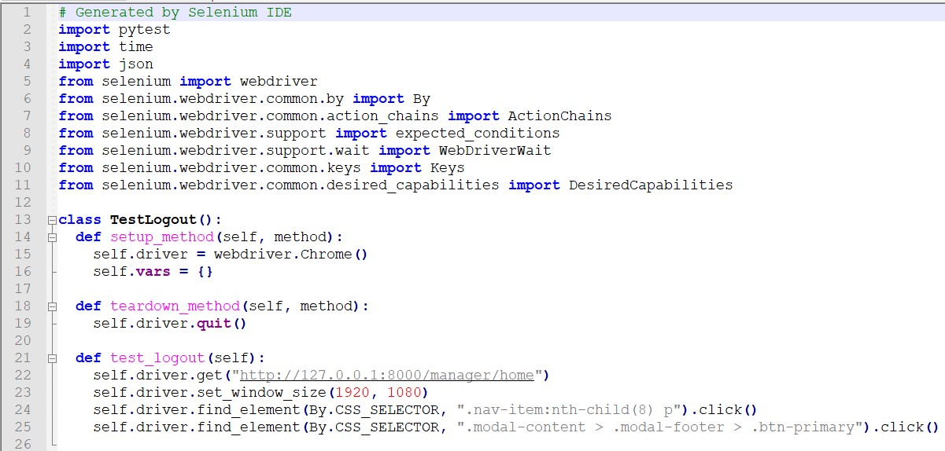

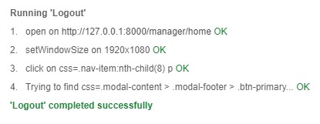

Manager: Login🡪 Logout

|  |  |  |  |  |
| --- | --- | --- | --- | --- |
| Test ID | R-003 | | | |
| Use Case | Manager : Login🡪 Logout | | | |
| Test Description | Allow the user to register for a new account. | | | |
|  | Test Data | Expected Output | Actual Output | Remark(s) |
| Test Case 1: | Click log out button | Confirmation message will be displayed | Confirmation message will be displayed | Pass |
| Test Case 2: | Click cancel button in the confirmation message | Return to previous page | Return to previous page | Pass |
| Test Case 3: | Click log out button in the confirmation message | Directed to login page | Directed to login page | Pass |

* + 1. **System Testing**

Functional Requirements

1. Login

The first test starts when the user enters the URL, then the dashboard page will appear and the user selects the login page.

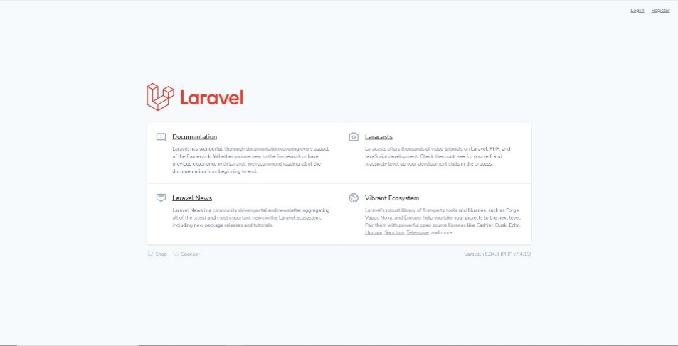

Login Page

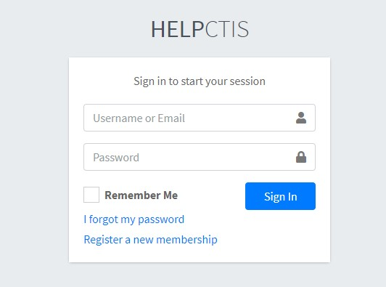

1. User leaves the form blank and notification will be appear.

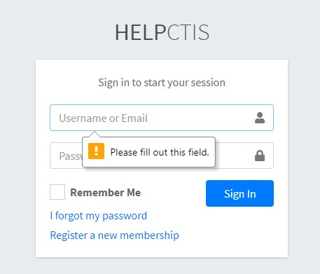

1. User input wrong data (username, email or password)

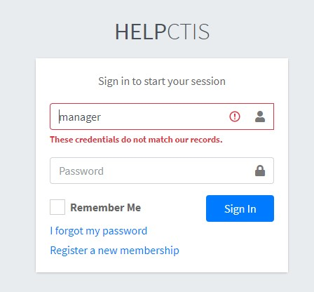

1. If user input correct data, it will immediately directed to the dashboard page according to the role.

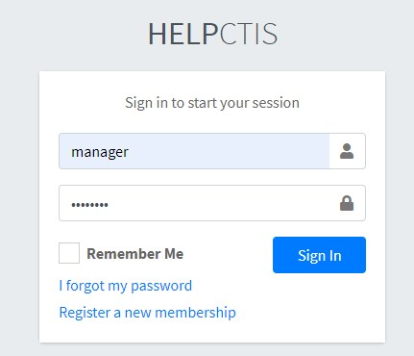

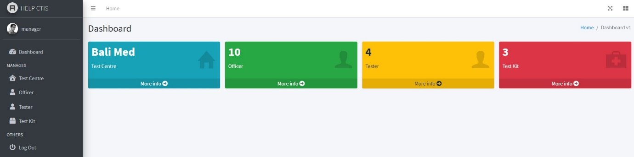

|  |  |  |  |  |
| --- | --- | --- | --- | --- |
| Test ID | R-001 | | | |
| Use Case | Login | | | |
| Test Description | Testing login process by the user. To ensure the user can login to the system. | | | |
|  | Test Data | Expected Output | Actual Output | Remark(s) |
| Test Case 1: | Login page | Show the login page | Show the login page | Pass |
| Test Case 2: | User fill the form with valid username and password  1. Username : “manager”  2. Password: “manager” | Successfully login and directed to the dashboard page | Successfully login and directed to the dashboard page | Pass |
| Test Case 3: | User fill the form with invalid username  1. Username : “user”  2. Password: “manager” | A warning message that user input wrong username will be notify | A warning message that user input wrong username will be notify | Pass |
| Test Case 4: | User fill the form with invalid password  1. Username : “manager”  2. Password: “user” | A warning message that user input wrong password will be notify | A warning message that user input wrong password will be notify | Pass |
| Test Case 5: | User do not fill the form  1. Username :  2. Password: | A warning message that the user must fill the field will be displayed | A warning message that the user must fill the field will be displayed | Pass |

1. Register Test Centre

Register Test Center can be done when the user has selected the Test Center menu on the navbar and then press Add Test Center button on the dashboard page.

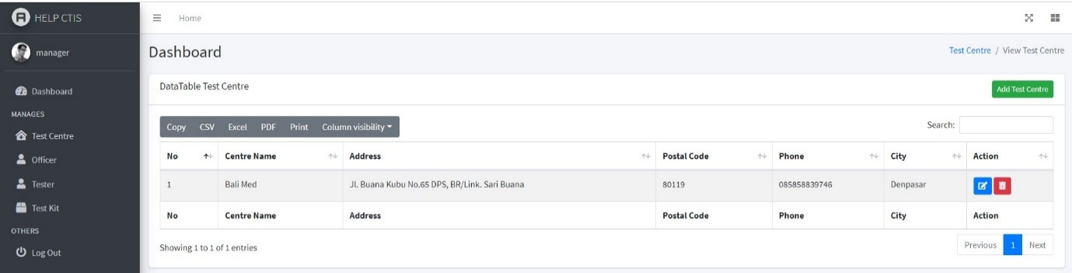

Register Test Centre Page

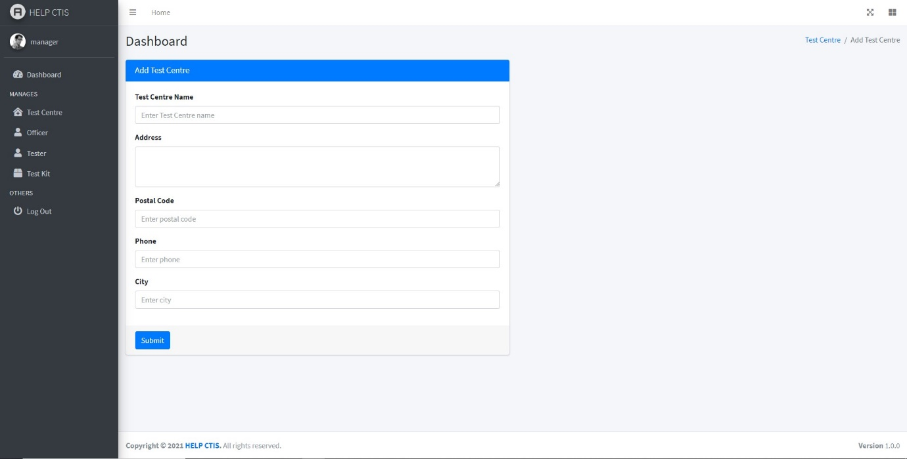

1. User input blank data form and notification would be appear.

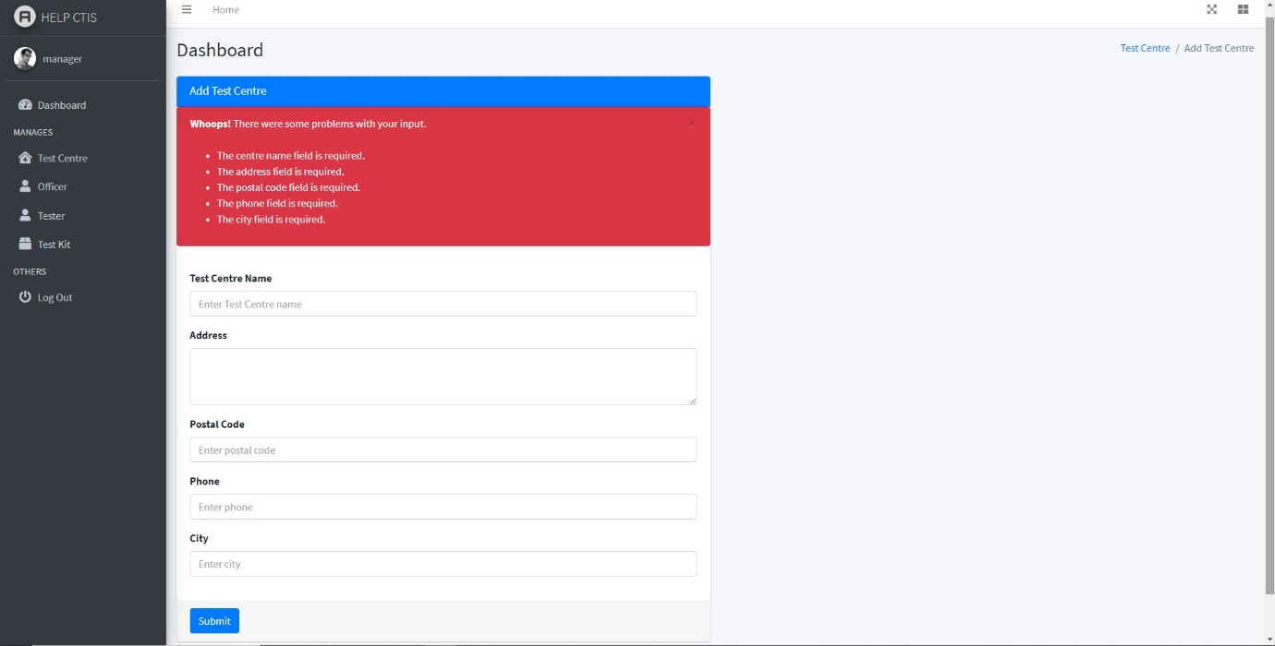

1. When the user succeeds in entering the Test Centre Data.

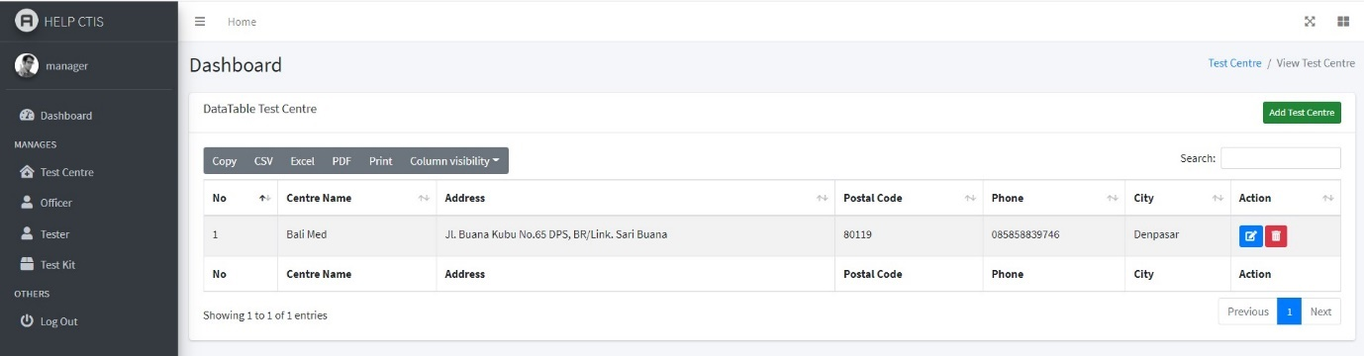

c. When the user has previously created Test Center data

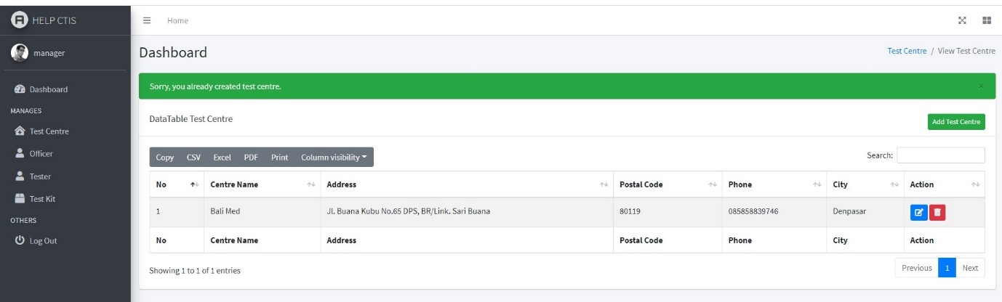

|  |  |  |  |  |
| --- | --- | --- | --- | --- |
| Test ID | R-002 | | | |
| Use Case | Register Test Centre | | | |
| Test Description | Testing register process for new account. To ensure the user register to the system. | | | |
|  | Test Data | Expected Output | Actual Output | Remark(s) |
| Test Case 1: | Register Test Centre | Click the Add Test Centre button and show the register form | Click the Add Test Centre button and show the register form | Pass |
| Test Case 2: | User fill the form with valid data  1. Test Centre Name: “Bali Med”  2. Address: “Jl. Buana Kubu No. 65 DPS, BR/Link. Sari Buana”  3. Postal Code: “80119”  4. Phone: “085858839746”  5. City: “Denpasar” | Successfully register will be notify and displayed on the Test Centre Dashboard | Successfully register will be notify and displayed on the Test Centre Dashboard | Pass |
| Test Case 3: | User fill the form with same data that already registered  1. Test Centre Name: “Bali Med”  2. Address: “Jl. Buana Kubu No. 65 DPS, BR/Link. Sari Buana”  3. Postal Code: “80119”  4. Phone: “085858839746”  5. City: “Denpasar” | A warning message already created Test Centre will be notify | A warning message already created Test Centre will be notify | Pass |
| Test Case 4: | User do not fill the form  1. Test Centre Name:  2. Address:  3. Postal Code:  4. Phone:  5. City: | A warning notification will be displayed that the user must fill the field | A warning notification will be displayed that the user must fill the field | Pass |

1. Logout

When the user wants to end the session, the user can log out of the account through the Log Out menu on the navbar



Confirmation message when the user press the Log Out button

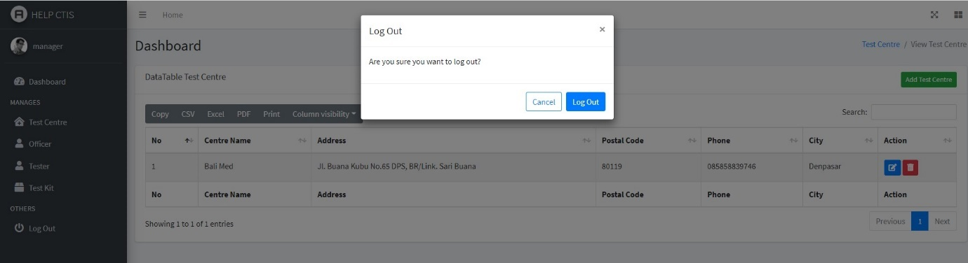

1. If the user press the cancel button on the confirmation message, will return to the previous page.



1. If the user press the log out button on the confirmation message, will be directed to the login page.



|  |  |  |  |  |
| --- | --- | --- | --- | --- |
| Test ID | R-003 | | | |
| Use Case | Logout | | | |
| Test Description | Testing the logout function. User able to logout from the system | | | |
|  | Test Data | Expected Output | Actual Output | Remark(s) |
| Test Case 1: | Click logout button | Confirmation message will be displayed | Confirmation message will be displayed | Pass |
| Test Case 2: | Click cancel button in the confirmation message | The system will return to previous page | The system will return to previous page | Pass |
| Test Case 3: | Click log out button in the confirmation message | The system will show the login page | The system will show the login page | Pass |

Non Functional Requirements

1. Security & Integrity: The login feature to identify users who are connected to the HELP CTIS system.



Non-Func – run on Google Version 89.0.4389.114 (Official Build) (64-bit)

|  |  |  |  |  |
| --- | --- | --- | --- | --- |
| Test ID | R-001 | | | |
| Use Case | Password for login is encrypted | | | |
| Test Description | Password login will be encrypted | | | |
|  | Test Data | Expected Output | Actual Output | Remark(s) |
| Test Case 1: | 1. Username = “manager” 2. Password = “manager” | Password in the text box will be “*****” and in the database table the password is encrypted | Password in the text box will be “*****” and in the database table the password is encrypted | Pass |

1. Usability: Website system that is easy to access anywhere on PC, laptop, or smartphone.



|  |  |
| --- | --- |
|  |  |

1. Correctness: Data alignment where the data entered by the user will be complete sent to the database.

Data entered by the user.

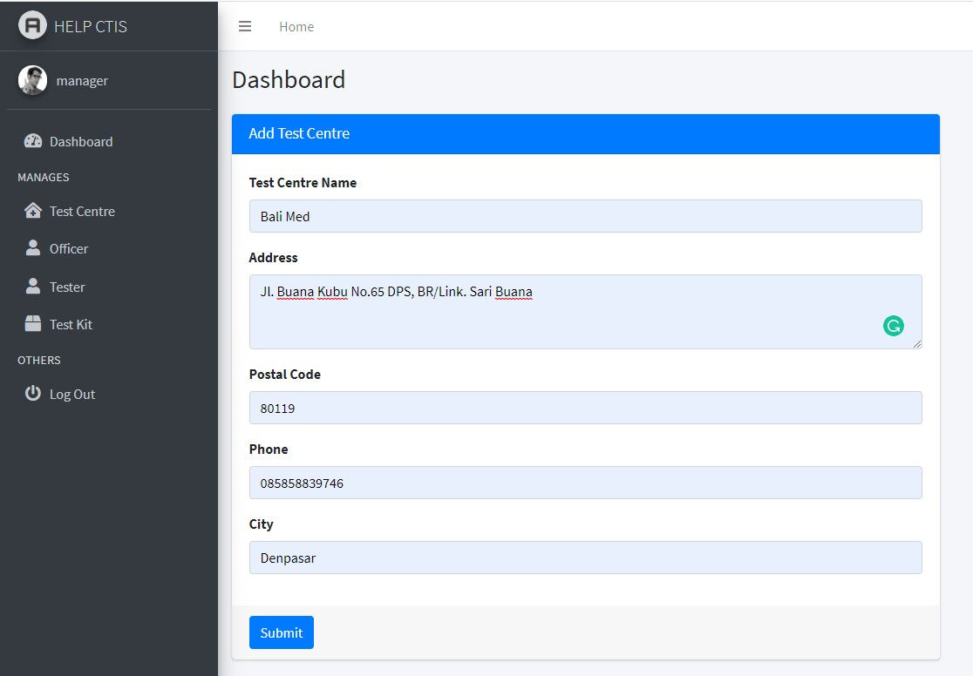

Data stored in the database.



* 1. **Test Analysis Report**

We have run all of the necessary testing for the system on the functional and non-functional requirements. Based on the testing results, we can conclude that the system is operationally stable and followed all the requirements. The system and codes are functional and have passed the unit, integration, and system the testing phase. We did not find any bugs or errors on our system during our testing. We can ensure that all functions perform flawlessly in accordance with the requirements that have been assigned to them.

* 1. **Updated Gantt Chart**

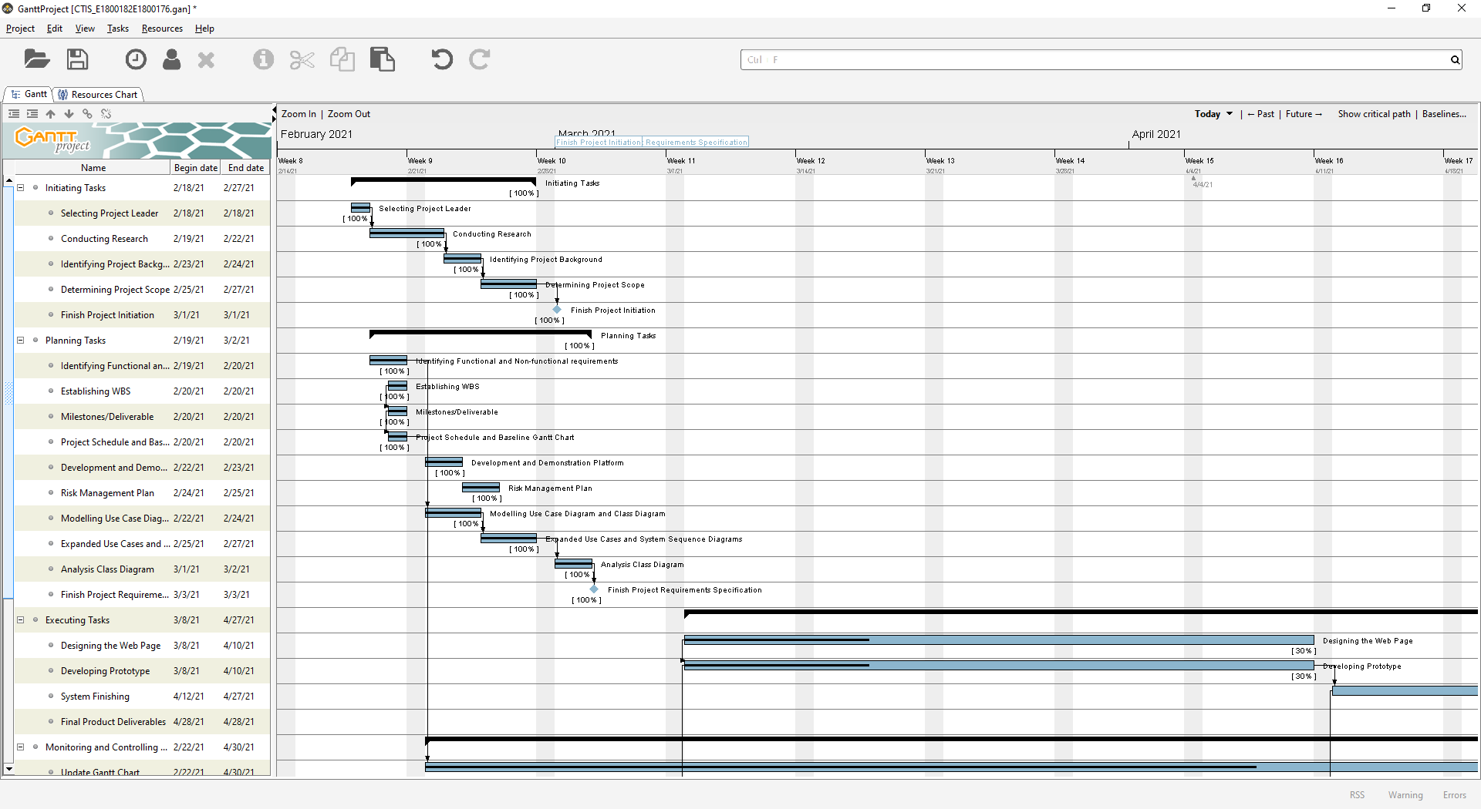

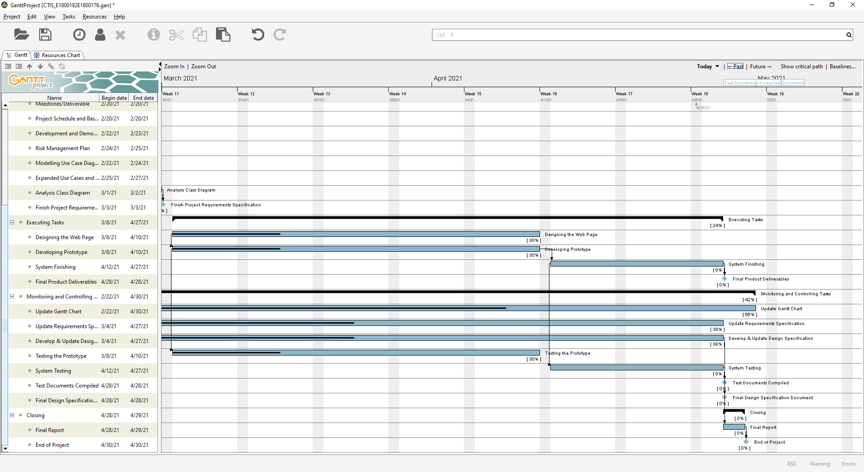

Figure 22. Gantt Chart

* 1. **Collaboration via GitHub**

GitHub page link: <https://github.com/awidyaandika/help-ctis>

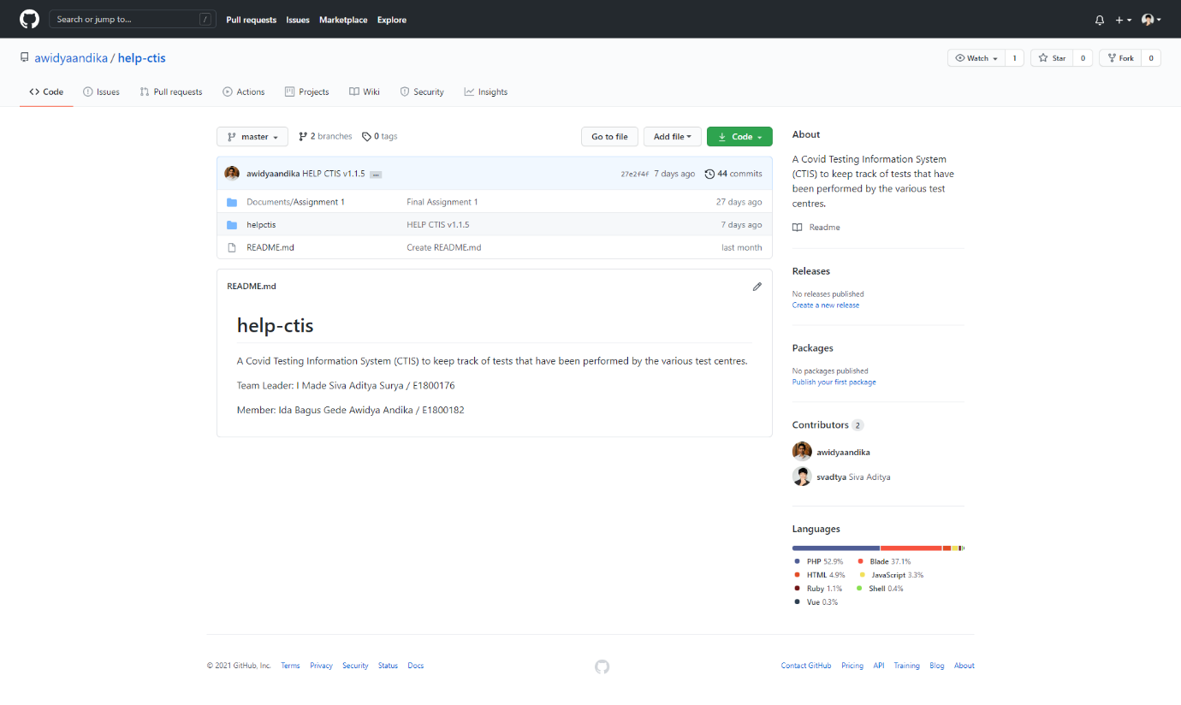

Figure 23. GitHub Main Page

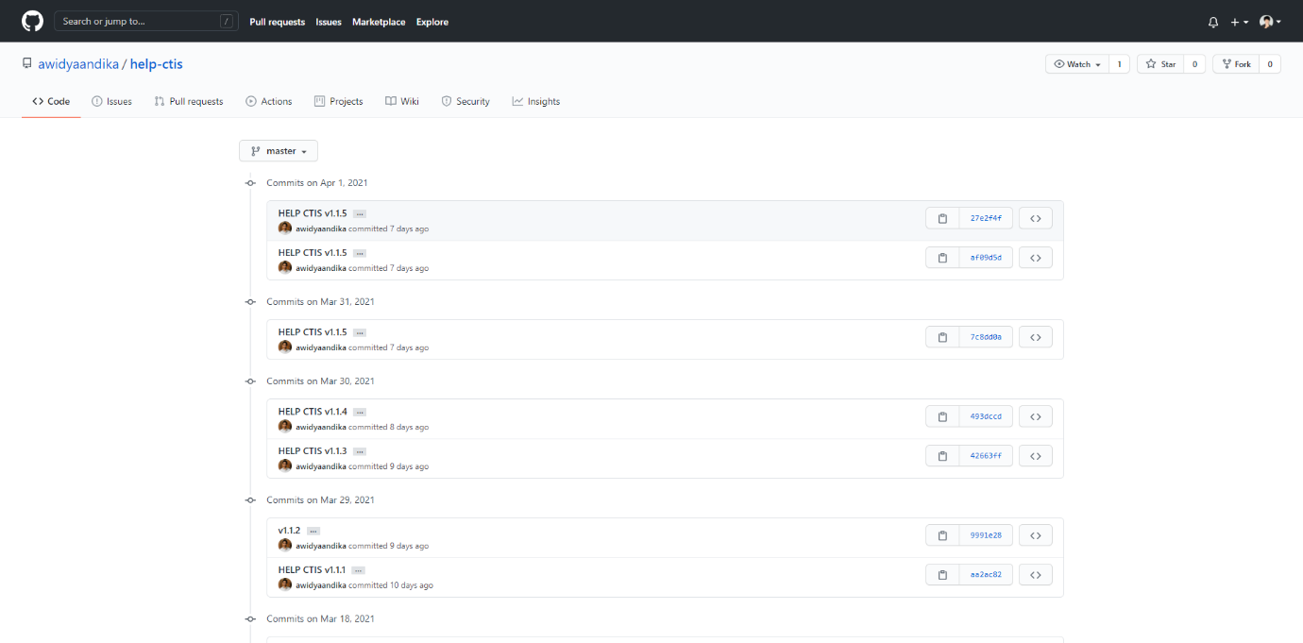

Figure 24. GitHub Commits History

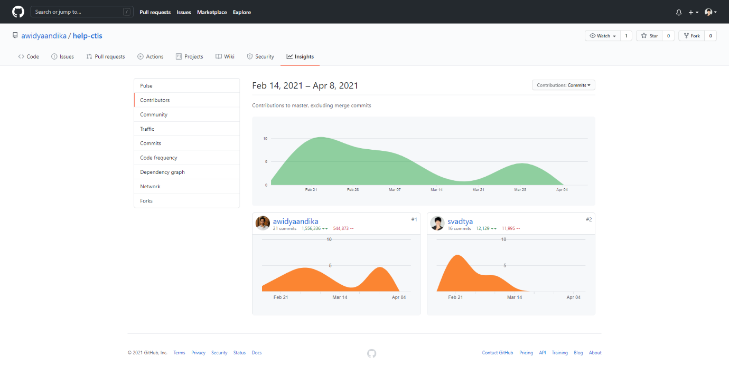

Figure 25. GitHub Contributors Insights

# **Bibliography**

Sommerville, I. (2016). *Software engineering 10th Edition*. Pearson Education.

# **Appendix A: Peer Presentation Evaluation**

Reviewer: Ida Bagus Gede Awidya Andika (E1800182) Reviewing: I Made Siva Aditya Surya (E1800176)

|  |  |  |  |  |  |
| --- | --- | --- | --- | --- | --- |
| **Skills** | **4 Advanced - exceeds expectations** | **3 Competent - meets expectations** | **2 Progressing - does not fully meet expectations** | **1 Beginning - does not meet expectations** | **Score** |
| Contributions & Attitude | Always cooperative. Routinely offers useful ideas. Always displays positive attitude. | Usually cooperative. Usually offers useful ideas. Generally displays positive attitude. | Sometimes cooperative. Sometimes offers useful ideas. Rarely displays positive attitude. | Seldom cooperative. Rarely offers useful ideas. Is disruptive. | 4 |
| Cooperation with Others | Did more than others. Highly productive.  Works extremely well with others. | Did own part of workload. Cooperative. Works well with others. | Could have shared more of the workload. Has difficulty. Requires structure, directions, and  leadership. | Did not do any work. Does not contribute. Does not work well with others. | 3 |
| Focus, Commitments | Tries to keep people working together.  Almost always focused on the task. Is very self- directed. | Does not cause problems in the group. Focuses on the task most of the time. Can count on this person. | Sometimes focuses on the task. Not always a good team member. Must be prodded and  reminded to keep on task. | Often is not a good team member. Does not focus on the  task. Lets others do the work. | 3 |
| Ability to Communicate | Always listens to, shares with, and supports the efforts of others.  Provides effective feedback. Relays a lot of relevant information. | Usually listens to, shares with, and supports the efforts of others.  Sometimes talks too much. Provides some effective feedback. Relays some basic information that relates to the topic. | Often listens to, shares with, and supports the efforts of others. Usually does most of the talking. Rarely listens to others. Provides little feedback. Relays very little information that relates to the topic. | Rarely listens to, shares with, or supports the efforts of others. Is always talking and never listens to others. Provides no feedback. Does not relay any information to teammates. | 3 |

|  |  |  |  |  |  |
| --- | --- | --- | --- | --- | --- |
| Accuracy - documentation/coding etc | Work is complete, well- organized, error-free, and done on time or early. | Work is generally complete, meets the requirements of the task, and is mostly done on time. | Work tends to be disorderly, incomplete, inaccurate, and is usually late. | Work is generally sloppy and incomplete, contains excessive  errors, and is mostly late. | 3 |
|  | | | | TOTAL | 16/20 |

Questions:

1. How effectively did your group work?

In my opinion, our group has been working effectively. This can be achieved due to the neatly arranged and planned division of tasks from the start. For example, whether I or my group friends complement each other if there are problems that cannot be resolved individually, we also provide input and suggestions to each other so that this project can be better.

1. Were the behaviors of any of your team members particularly valuable or detrimental to the team? Explain.

In my opinion, my partner named Siva, has a perfectionist attitude, where he always looks at little things in detail. From this attitude, it has both positive and negative impacts. The positive thing is to minimize carelessness and mistakes when making a project, but the negative impact of this slows down the completion of a work on the project due to having to revise it to get the appropriate results. But I personally do not feel affected by his attitude because Siva and I have often worked on projects together.

1. What did you learn about working in a group from this project that you will carry into your next group experience (e.g. assignment 3)?

I have high appreciation commitment for this group has working on HELP CTIS project. With Siva in this group, it makes me feel motivated to carry out this project in an efficient, detailed and on time.

Reviewer: I Made Siva Aditya Surya (E1800176) Reviewing: Ida Bagus Gede Awidya Andika (E1800182)

|  |  |  |  |  |  |
| --- | --- | --- | --- | --- | --- |
| **Skills** | **4 Advanced - exceeds expectations** | **3 Competent - meets expectations** | **2 Progressing - does not fully meet expectations** | **1 Beginning - does not meet expectations** | **Score** |
| Contributions & Attitude | Always cooperative. Routinely offers useful ideas. Always displays positive attitude. | Usually cooperative. Usually offers useful ideas. Generally displays positive attitude. | Sometimes cooperative. Sometimes offers useful ideas. Rarely displays positive attitude. | Seldom cooperative. Rarely offers useful ideas. Is disruptive. | 4 |
| Cooperation with Others | Did more than others. Highly productive.  Works extremely well with others. | Did own part of workload. Cooperative. Works well with others. | Could have shared more of the workload. Has difficulty. Requires structure, directions, and  leadership. | Did not do any work. Does not contribute. Does not work well with others. | 4 |
| Focus, Commitments | Tries to keep people working together.  Almost always focused on the task. Is very self- directed. | Does not cause problems in the group. Focuses on the task most of the time. Can count on this person. | Sometimes focuses on the task. Not always a good team member. Must be prodded and  reminded to keep on task. | Often is not a good team member. Does not focus on the  task. Lets others do the work. | 4 |
| Ability to Communicate | Always listens to, shares with, and supports the efforts of others.  Provides effective feedback. Relays a lot of relevant information. | Usually listens to, shares with, and supports the efforts of others.  Sometimes talks too much. Provides some effective feedback. Relays some basic information that relates to the topic. | Often listens to, shares with, and supports the efforts of others. Usually does most of the talking. Rarely listens to others. Provides little feedback. Relays very little information that relates to the topic. | Rarely listens to, shares with, or supports the efforts of others. Is always talking and never listens to others. Provides no feedback. Does not relay any information to teammates. | 3 |

|  |  |  |  |  |  |
| --- | --- | --- | --- | --- | --- |
| Accuracy - documentation/coding etc | Work is complete, well- organized, error-free, and done on time or early. | Work is generally complete, meets the requirements of the task, and is mostly done on time. | Work tends to be disorderly, incomplete, inaccurate, and is usually late. | Work is generally sloppy and incomplete, contains excessive  errors, and is mostly late. | 3 |
|  | | | | TOTAL | 18/20 |

Questions:

1. How effectively did your group work?

Our group has worked on this project quite effectively. We always carry out discussions and brainstorms before working on a task to equalize concepts among team members and avoid misunderstandings. In my opinion, we have divided the work of the task between the team members very well, which is in accordance with the abilities and experience of the team members so that all members can execute tasks properly.

1. Were the behaviors of any of your team members particularly valuable or detrimental to the team? Explain.

My team member Awidya Andika is a very cooperative person, hardworking, committed, and very knowledgeable in website development. All the tasks he does are always completed on time, sometimes even ahead of the set schedule. Even though his work is not always perfect, his persistence and hard work really helped me as the leader of this project. Without the contribution from Awidya Andika, the quality of our project would have been considerably diminished.

1. What did you learn about working in a group from this project that you will carry into your next group experience (e.g. assignment 3)?

I learned a lot from my team member Awidya Andika who is diligent and hardworking. As a leader, I often can't complete assignments on time. I began to reflect on myself and focus on improving my time management skills. So that the implementation of tasks in the next assignment can be carried out properly according to the schedule plan